

A level Psychology transition work for years 11-12
Name:

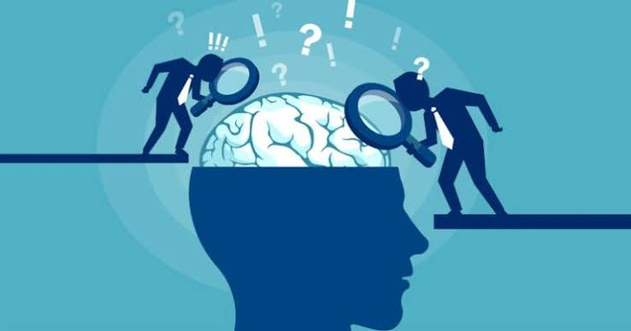

Welcome to psychology and the summer transition work.

The idea of this is to introduce you to some of the theories, ideas, concepts and studies that we investigate within psychology. We use the AQA specification.

Psychology will be a new subject to you so it is important that you gain as much information as you possibly can and that you see what this subject has to offer. It can be a big jump moving from GCSE’s to A levels and whilst psychology can be challenging it also brings in some great ideas, insight and understanding of the world and people around us.

Read through the tasks in this booklet and complete the project and bring with you on the first day you start in sixth form. We hope that you enjoy this project as you start your A level journey.

Have a great summer and we look forward to welcoming you in September !!!


To help you research this information – please don’t copy and paste big chunks from the internet. You need to phrase these in your own words.
Internet sites to visit to help you: Tutor2u (psychology), Youtube, Simply psychology, British Psychological society and any other credible websites you find.

Other internet sites I have used
-

please note them down

Part one -Some definitions and concepts – please find these out….

Concept | Definition
Psychology

Different types of experiments in psychology
Lab Experiment

Natural
Experiment

Field experiment

Observation

Case study

Validity

Reliability

Cognitive
psychology

Developmental
psychology

Biological
psychology

Evolution

Behaviourism

Social Learning theory

Psychodynamic theory

Part two: - Researching the different theories within psychology
Complete the sections within the boxes –

THE BIOLOGICAL APPROACH
How does the biological approach attempt to explain the causes of human behaviour? (depression, OCD, Schizophrenia)

Identify how the biological approach suggests psychological conditions should be treated.

The biological approach can be accused of being deterministic – what does this mean?

What does genotype and phenotype mean?

THE BEHAVIOURIST APPROACH
Who are the main founders of the behavioural approach?

When did this approach develop?

Identify the main study from each of the founders (they should both be using animals – rats/dogs)

Identify the main assumptions of this approach

What kinds of research methods do the behaviourists use?

Identify how this approach might explain phobias.

THE COGNITIVE APPROACH
What are the main assumptions of the cognitive approach?

Identify some areas in psychology that use the cognitive approach?

How does the cognitive approach explain human behaviour?

What therapy does the cognitive approach use – briefly explain it.

Part three: - researching a classic study.
Your task is to research one of the key studies that we use in psychology and at some point during the term you will need to recall this as a summary in test conditions. But you need to research it and make some notes (which can be added to later if needed).
Please select one from the following:
- Milgrams Study of obedience
- Zimbardo’s Stanford Prison Experiment
- Asch’s study of conformity
- Ainsworth’s strange situation
- Van Ijzendoorn and Kroonenberg’s cross cultural study of attachment - Bowlby’s 44 thieves study

Just type the name of the researcher into google to find out the information – simply psychology or tutor2u have some good information. Youtube helps explain it well.

You should produce a fact sheet based on one of these key studies above to include:
- The aim of the study
- The research methodology and procedures – what type of experiment, participants, what did they actually do in the study?
- What were their findings / results.
- What conclusions can be drawn from this experiment – ie what does this mean (any theories it supports)
- Any strengths or weaknesses from this experiment/study.

Use pictures if you can.

Please print and stick into this booklet.

Research on the study.

Part four: Recommended films, books and TED talks

🎬 Recommended Films

1. A Beautiful Mind (2001)
Synopsis:
Follows John Nash, a brilliant mathematician who develops schizophrenia and struggles to distinguish reality from hallucination.
Linked Topics:
- Psychopathology (schizophrenia)
- Diagnosis & classification
- Treatments (drug therapy, CBT)

2. The Stanford Prison Experiment / The Experiment (2015)
Synopsis:
Students take part in a simulated prison study; behaviour quickly changes as guards become authoritarian and prisoners submissive.
Linked Topics:
- Social influence
- Zimbardo’s research
- Conformity to social roles
- Ethical issues

3. Inside Out (2015)
Synopsis:
Animated film that explores how different emotions influence behaviour and memory in a young girl.
Linked Topics:
- Cognitive psychology
- Memory
- Emotional processes

4. The Truman Show (1998)
Synopsis:
A man unknowingly lives his entire life inside a staged reality TV show and begins to question what is real.
Linked Topics:
- Perception and reality
- Social control
- Nature vs nurture

5. Black Swan (2010)(teacher discretion)
Synopsis:
A dancer becomes increasingly obsessive and experiences psychological breakdown while striving for perfection.
Linked Topics:
- OCD and anxiety
- Psychopathology
- Stress

6. 12 Angry Men (1957)
Synopsis:
A jury debates the fate of a teenage boy, and one dissenting juror gradually influences the group to reconsider their verdict.
Linked Topics:
- Conformity
- Minority influence (Moscovici)
- Group dynamics
- Bias

📚 Recommended Books

1. The Man Who Mistook His Wife for a Hat – Oliver Sacks
- Case studies of unusual brain disorders
- Topics: Neuropsychology, brain localisation

2. The Psychopath Test – Jon Ronson
- Explores how psychopathy is diagnosed and misunderstood
- Topics: Classification, validity, psychopathology

3. Opening Skinner’s Box – Lauren Slater
- Retells famous psychological studies in an engaging way
- Topics: Milgram, Skinner, ethics

4. Thinking, Fast and Slow – Daniel Kahneman(challenge)
- Explains how we think and make decisions
- Topics: Cognitive psychology, biases

5. Prisoners of Geography – Tim Marshall
- Explains how environment shapes behaviour and decisions
- Topics: Environmental influences, nature vs nurture

🎤 TED Talks

1. Philip Zimbardo – The Psychology of Evil
Watch here: https://www.youtube.com/watch?v=OsFEV35tWsg
Topics: Social influence, conformity, situational explanations [youtube.com]

2. Elizabeth Loftus – How Reliable is Your Memory?
Watch here: https://www.youtube.com/watch?v=PB2OegI6wvI
Topics: Memory, eyewitness testimony [youtube.com]

3. Dan Gilbert – The Surprising Science of Happiness
Watch here: https://www.youtube.com/watch?v=4q1dgn_C0AU
Topics: Cognitive psychology, decision-making [youtube.com]

4. Steven Pinker – The Decline of Violence
Watch here: https://www.youtube.com/watch?v=ramBFRt1Uzk
Topics: Aggression, nature vs nurture [youtube.com]

5. Ruby Wax – What’s So Funny About Mental Illness?
Watch here: https://www.youtube.com/watch?v=mbbMLOZjUYI
Topics: Mental health, stigma, depression [youtube.com]

✏️ TED Talk Task
Choose ONE TED Talk from the list above and complete the following:
Write a 300–400 word summary that includes:
- What the talk is about
- The key psychological ideas explained
- How it links to what you already know or have studied
- Your opinion: Do you agree with the speaker? Why?

🧠 Optional Extension Questions
- Are we born evil or shaped by our environment?
- Can we trust our memories?
- What causes mental illness?
- Why do people conform?

BRING THE COMPLETED TASKS WITH YOU FOR THE FIRST LESSON IN SEPTEMBER !

Thank You
Ms Oyebola
Head of Psychology

