

Exam board: OCR
Course name: Level 3 Cambridge Extended Certificate in Sport and Physical activity.
Guided learning hours: 360 GLH equivalent to 1 A Levels
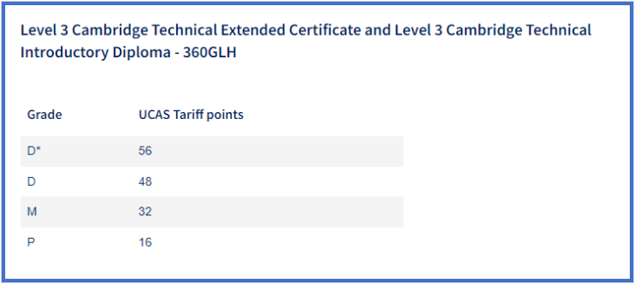

Recommended reading material: Cambridge Technicals Level 3 Sport and Physical Activity textbook by Authors: Suzanne Bointon, Helen Bray, Scott Chapman, James Martin, Alister Myatt, Annette Short. Publisher: Hodder Education.

Recommended websites: https://www.bbc.co.uk/bitesize/examspecs/ztrcg82 https://www.sportengland.org/ https://www.brianmac.co.uk/

Link to specifications- Diploma/Sports coaching: https://www.ocr.org.uk/qualifications/cambridge-technicals/sport-and-physical-activity/units/#level-3

The Structure and Function of the Skeletal System Location of Major Bones:
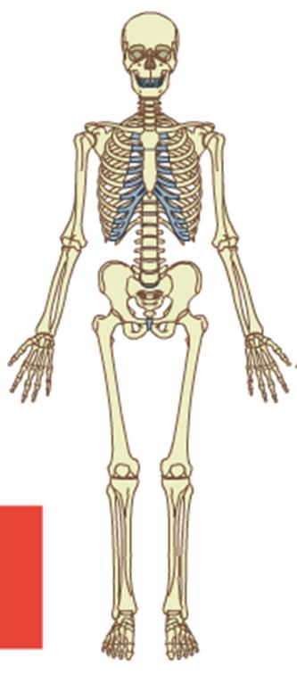

The Structure and Function of the Skeletal System
Axial and Appendicular Skeleton

Axial Skeleton – central core of the human body housing and protecting its vital organs e.g. cranium, ribs and vertebrate.

Appendicular Skeleton – the bones of the limbs e.g. femur

Functions of the Skeleton
The skeleton has five functions, each of which are described below:

- Give shape and support to the body – therefore keeping the body upright and giving the body posture.
- Allows movement – provides areas for the muscles to attach to the skeleton via tendons, so that muscles can pull on the bones.
- Protects internal organs – the axial skeleton protects vital organs, for example, the cranium protects the brain, the ribs protects the lungs, and the sternum protects the heart.
- Produces blood cells – red and white blood cells are produced in the bone marrow. Red blood cells transport Oxygen around the body to the working muscles, and white blood cells help to fight infection.
- Stores minerals – minerals are stored in the bones, such as iron, potassium and calcium, for example, iron helps to transport Oxygen to the working muscles in haemoglobin, and calcium is needed to help repair and build bone.

The Structure and Function of the Skeletal System
Types of bones

Type of bone | Description | Function | Examples
Flat | Strong, flat plates of bone | Protects vital organs | Cranium, Sternum, Ribs,  Scapula
Short | As wide as they are long (cubic  shaped) | Provide support and stability with  little movement | Carpals, Tarsals
Long | Are longer that it is wide with growth plates at either end.  Having a hard outer surface of compact bone and a spongy  inner | Act as leavers by creating large movement | Clavicle, Humerus, Radius, Ulna, Meta-  Tarsals, Meta Carpals, Phalanges, Tibia, Fibula, Femur
Irregular | Do not fall into any category, due to their non-uniform shape | Protection of the nervous tissue  e.g. vertebrae protects the  spinal cord) | Vertebrae
Sesamoid | Are usually short or irregular bones, embedded in a  tendon | Serves to protect a tendon | Patella

Structure and function of the vertebral column
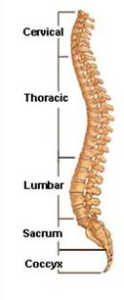

 | Cervical | Thoracic | Lumbar | Sacral | Coccyx
Number of  bones | 7 | 12 | 5 | 5 | 4
Where in the  body | Neck | Chest | Lower back | Pelvic area | Base of  spine
Function | Help turn the neck and protect spinal cord. | Attached to the ribs and help with breathing: protect spinal cord | Provide greatest amount of movement occurs so bears a lot of weight.  Protect spinal cord, the largest vertebrae in  the body. | They are fused together and make up part of the pelvic girdle. | They are fused together to form the base of the spine
What is attached | Neck Muscles | Ribs | Back Muscles | Joins spine, pelvic &  girdle | Base of spine attached

only to sacral
vertebrae

The Structure and Function of the Skeletal System
Classifications of joints

Fixed/fused joint is where two bones come together in the body but are unable to move e.g. cranium, pelvis

Slightly movable/ cartilaginous where there is a small amount movement permitted at these joints which are separate by cartilage e.g. vertebrate
Freely movable joint is also known as a synovial joint which allows a range of movement e.g. knee.

The Structure and Function of the Skeletal System

Type of synovial joints

Type of Synovial Joint | Location in Body | Articulating Bones
Hinge Joint | Elbow | Humerus Radius  Ulna
 | Knee | Femur  Tibia
Ball & Socket Joint | Shoulder | Humerus Scapula
 | Hip | Pelvis  Femur
Pivot Joint | Neck | Cervical  Thoracic
Gliding | Hands & Feet | Tarsals  Carpals
Saddle | Fingers & Thumbs | Metatarsals  Metacarpals

Condyloid | Wrist | Wrist  Carpal

The Structure and Function of the Skeletal System

Types of Movement at a Hinge Joint

Type of Movement | Definition | Sporting Example
Flexion | Decreasing the angle at  a joint | Preparing to kick a  football
Extension | Increasing the angle at  a joint | Overhead clear in  badminton
The Structure and Function of the Skeletal System

Types of Movement at a Ball and Socket Joint

Type of Movement | Definition | Sporting Example
Flexion | Decreasing the angle at  a joint | Arm action in  backstroke
Extension | Increasing the angle at a  joint | Shoulder action in a  tennis serve
Abduction | Moving a  limb away from the  middle of the body | Arm action in butterfly stroke
Adduction | Moving a  limb towards the middle of the body | ‘Squeeze’ action in a rugby tackle
Rotation | Turn the bone around the longitudinal axis | Turning your foot out to control a football / Turning your wrist to add top spin in table  tennis

Circumduction | A combination of abduction, adduction,  flexion and extension | Front crawl action / cricket bowl

The Structure and Function of the Skeletal System

Types of Movement in other synovial Joints

Joint | Movements which can occur
Pivot | Rotation
Gliding | Flexion and extension
Saddle | Flexion, extension, adduction, adduction and circumduction but  NO axial rotation
Condyloid | Flexion, extension, adduction,  adduction and circumduction

The Structure and Function of the Skeletal System
Other Components of a Joint

There are three other components of a joint. You must know what these are, and what their function is:

- Cartilage:
- Function: To reduce friction and act as a shock absorber

  - Ligament:
- Function: To join bone to bone, and to stabilise the joint to prevent dislocation

  - Tendon:

- Function: To join muscle to bone, and to produce the power needed to create movement

The Structure and Function of the Muscular System

Topics covered in this area:
- Location of major muscles and their function
- Main muscle acting at synovial joint
- Types of muscle function
- Type muscle contraction
- Structure and function of muscle fibres

The Structure and Function of the Muscular System
Location of Major Muscles and their Function The Structure and Function of the Muscular System
Types of muscle functions

Key words that you need to know:

- Antagonistic Pairs – where muscles work together to produce movement, with one muscle contracting (agonist) and the other relaxing (antagonist)

- Agonist – the prime mover; the muscle that contracts and shortens
- Antagonist – the muscle that relaxes and lengthens

- Fixator – stabilises the joint and assists the agonist with movement

Movement | Agonist | Antagonist | Fixator
Flexion at elbow | Bicep | Tricep | Trapezius
Extension at elbow | Tricep | Bicep | Trapezius
Flexion at knee | Hamstring | Quadricep | Gluteal
Extension at knee | Quadricep | Hamstring | Gluteal
Abduction at  shoulder | Deltoid | Latissimus Dorsi | Trapezius
Adduction at  shoulder | Latissimus Dorsi | Deltoid | Trapezius
Plantarflexion | Gastrocnemius
Extension at hip | Gluteus maximus

The Structure and Function of the Muscular System
Muscle Contractions

Key words that you need to know

- Isotonic (meaning same tension) are those which cause the muscle to change length as it contracts and causes movement of a body part.
Two types of isotonic contacts
- Concentric: are those which cause the muscle to shorten as it contracts. An example is bending the elbow from straight to fully flexed, causing a concentric contraction of the Biceps Brachii muscle. Concentric contractions are the most common type of muscle contraction and occur frequently in daily and sporting activities.
- Eccentric: the opposite of concentric and occur when the muscle lengthens as it contracts. For example, when kicking a football, the Quadriceps muscle contracts concentrically to straighten the knee and the Hamstrings contract eccentrically to decelerate the motion of the lower limb. This type on contraction puts a lot of strain through the muscle and is commonly involved in muscle injuries
- Isometric: occur when there is no change in the length of the contracting muscle. This occurs when carrying an object in front of you as the weight of the object is pulling your arms down but your muscles are contracting to hold the object at the same level.
- Isokinetic: are similar to isotonic in that the muscle changes length during the contraction, where they differ is that Isokinetic contractions produce movements of a constant
speed. Examples of using isokinetic contractions in day-to-day and sporting activities are rare. The best is breast stroke in swimming, where the water provides a constant, even resistance to the movement of adduction

The Structure and Function of the Muscular System
Structure and function of muscle fibres

 | Slow Twitch (Type 1) | Fast Oxidative Glycolytic (FOG)  (Type 2A) | Fast twitch glycolytic  (FTG) (Type 2b)
Functional
Speed of  contraction | Slow | Fast | Very Fast
Force of  contraction | Low | High | High
Resistance to  fatigue | Very High | Moderate | Low
Activity use | Aerobic | Long term  anaerobic | Short term  anaerobic
Structural
Mitochondrial  density | High | Moderate | Low
Capillary density | High | Moderate | Low
Glycogen  capacity | Low | High | High
Motor neuron  size | Small | Large | Very Large
Major Storage  fuel | Triglycerides | CP, Glycogen | CP, Glycogen
Activity suited | Marathon runner  Tri athlete | Games Players Middle distances athletes | Sprinters Field Events (Any explosive  movement)

(Any endurance
athlete)

Structure and Function of the Cardiovascular System

Topics covered in this area:

- Structure of the heart and pathway of blood through it
- Double Circulatory System (including pulmonary and systemic circulation)
- Different types of blood vessels
- Key word definitions and the relationship between them
- Components and functions of blood
- Vascular shunt mechanism

Structure and Function of the Cardiovascular System

Structure of the Heart and the Pathway of Blood through it

Pathway of Blood Through the Heart: Deoxygenated Blood:
- Deoxygenated blood enters the heart through the vena cava

- The deoxygenated blood then enters the Right Atrium

- The blood passes through the Tricuspid Valve

- Into the Right Ventricle

- Through the Semi-Lunar Valve

- And out of the heart through the Pulmonary Artery to the lungs, where the blood will get oxygenated

Oxygenated Blood:

- Oxygenated blood is returned to the heart in the Pulmonary Vein
- The oxygenated blood enters the Left Atrium

- The blood passes through the Bicuspid Valve

- Into the Left Ventricle

- Through the Semi-Lunar Valve

- And out of the heart through the Aorta to the body, delivering oxygenated blood to the working muscles

Structure and Function of the Cardiovascular System

Double Circulatory System (including Pulmonary and Systemic Circulation)

Pulmonary Circulation:

This is the transport of blood between the heart and the lungs. It transports deoxygenated blood away from the heart to the lungs, so that it can be oxygenated.
Systemic Circulation:

This is the transport of blood between the heart and the rest of the body (working muscles). It transports oxygenated blood to the working muscles in order for them to function.

Structure and Function of the Cardiovascular System

Different Types of Blood Vessels

There are three different types of blood vessels that you must know. You must know their structure/features (these two words mean the same thing) and their function (job).
This table below will help you to do this:

Blood Vessel | Structure/Feature | Function/Role
Artery | - Thick walls  - Elastic walls  - Small lumen  - No valves  - Smaller version of  these are arterioles | - Transport  blood Away from the heart  - Transport blood at high pressure
Vein | - Thin walls  - Large lumen  - Valves to prevent the backflow of blood  - Smaller version of  these are venules | - Transport  blood IN towards the heart  - Transport blood at low pressure
Capillary | - One call thick wall  - Single layer of cell in wall  - Semi-permeable wall (allows some things, e.g. gas and nutrients to pass  through) | - Allows gas exchange to occur in muscles and alveoli  - Allows nutrients and waste products to pass through

Structure and Function of the Cardiovascular System

Key Word Definitions and the Relationship between Them

There are three key words that you must know in relation to the Cardiovascular System:

  - Heart Rate (HR) – the number of times the heart beats per minute, measured in beats per minute (bpm)

  - Stroke Volume (SV) – the volume of blood ejected from the heart per beat

  - Cardiac Output (Q) – the volume of blood ejected from the heart per minute

If you are ever asked for the relationship between words, it is asking for an equation.

The relationship between these words is:

HR x SV = Q

Extension:

A person, who has a resting heart rate of below 60 beats per minute, suffers from bradycardia. This is a good indication of fitness, with a lower resting heart rate demonstrating a higher level of fitness.

Structure and Function of the Cardiovascular System

Components and functions of blood
The Red Blood Cell
- Contain Haemoglobin which carries oxygen
- To transport Oxygen to the working muscles
- To transport Carbon Dioxide to the lungs

The white blood cells
- Are part of the immune system
- Fight infections and diseases by using antibodies and anti-toxins
- Found in bone marrow

Platelets
- Clump together to forms clots
- Protect the body by stopping bleeding

Plasma
  - Mainly made of water and surrounds blood cells
  - Carries carbon dioxide, hormones and waste
  - Maintains blood pressure
  - Regulates temperature

When exercising blood does the following things:

Transports nutrients and waste
Delivers oxygen to the working muscles Removes heat (temperature regulation) Dilutes/carries away lactic acid

Structure and Function of the Cardiovascular System Vascular shunt system

    - Vascular shunt mechanism – the arterioles that supply muscle tissue experience vasodilation and this increases the blood flow to the muscles, vasoconstriction of the arterioles that supply other organ such as the liver means that blood flow is lessened to these organs that do not require as much blood supply.
    - The capillaries that supply the skeletal muscles the
precapillary sphincters (valves) open up and blood flow is again increased.

This occurs when more blood is distributed to the working muscles and less to the non-essential organs

Structure and Function of the Respiratory System

Topics covered in this area:

    - The structure of the lungs and their roles
    - The pathway of air through the Respiratory System

    - The role of the respiratory muscles in breathing
    - Key word definitions and the relationship between them
    - Gas exchange in the alveoli
    - Aerobic and Anaerobic exercise

The Structure and Function of the Respiratory System

Structure | Roles
Nasal Cavity (Nose) | Is a hollow space within the nose that is lined with hair and mucus membrane. This allows it to warm, moisturise and filter air entering  the body.
Epiglottis | Is to seal of the windpipe during  eating, so that food is not inhaled.
Pharynx (Throat) | Acts as a passageway for food on its way to the stomach and for air en route to the lungs. The mucosal epithelium in the pharynx is thicker than elsewhere in the respiratory tract as it has to protect the tissues from any abrasive and chemical  trauma caused by food.
Larynx (voice box) | It allows air to be directed into the respiratory organs for gas  exchange
Trachea (Windpipe) | Provides air to flow to and from the  lungs
Bronchi | Main passageway into
Bronchioles | Ensures that incoming air is  supplied to each alveolus
Alveoli | Tiny air sacs at the end of bronchioles, where gaseous  exchange happens

The pathway of air through the respiratory system is as follows:
- Air enters through the Nose and Mouth
- Into the Epiglottis
- Into the Pharynx
- Into the Larynx
- Into the Trachea
- Into the Bronchi
- Into the Bronchioles
- Into the Alveoli
- Air diffuses from the Alveoli into the Red Blood Cells

There are two main Respiratory Muscles that you must know. You need to know their role in inspiration (breathing in) and expiration (breathing out), and how this helps us to inspire and expire.

The two Respiratory Muscles are:

  - The Diaphragm
  - The Intercostal Muscles

The Role of the Respiratory Muscles in Inspiration at Rest:
- The intercostal muscles contract

- This lifts the rib cage upwards and outwards

- The diaphragm contracts and flattens

- This increases the size of the thoracic cavity

- Which decreases the pressure in the lungs, so that it is lower than the pressure outside of the body
- This causes a diffusion gradient

- Air diffuses into the lungs until an equilibrium is reached

The Role of the Respiratory Muscles in Expiration at Rest:
- The intercostal muscles relax

- This causes the rib cage to move inwards and downwards

- The diaphragm relaxes and domes

- This decreases the size of the thoracic cavity

- Which increases the pressure in the lungs, so that it is higher than the pressure outside of the body
- This causes a diffusion gradient

- Air diffuses out of the lungs until an equilibrium is reached

Extension Information

Inspiration changes during exercise:

Additional muscles are involved in inspiration during exercise. These are the:

  - Sternocleidomastoid
  - Scalene
  - Pectorals
These become involved to lift the rib cage further upwards and outwards. This increases the size of the thoracic cavity even further, which reduces the pressure in the lungs even further. This creates a larger diffusion gradient, so that more air can diffuse into the lungs.

The Structure and Function of the Respiratory System
Key Word Definitions and the Relationship between Them

There are three key words that you must know in relation to the Respiratory System:

  - Breathing Rate (f) – the amount of times we breathe per minute

  - Tidal Volume (TV) – the volume of air inspired or expired per breath

  - Minute Ventilation (VE) – the volume of air inspired or expired per minute

If you are ever asked for the relationship between words, it is asking for an equation.

The relationship between these words is:

f x TV = VE
The Structure and Function of the Respiratory System

Gas Exchange at the Alveoli

You need to know the following steps of gas exchange at the alveoli:

- There is a high pressure of Oxygen in the Alveoli

- There is a low pressure of Oxygen in the Capillary

- There is a high pressure of Carbon Dioxide in the Capillary

- There is a low pressure of Carbon Dioxide in the Alveoli

- This causes a Diffusion Gradient

- The Oxygen diffuses from the Alveoli to the Capillary
- The Carbon Dioxide diffuses from the Capillary to the Alveoli

- This diffusion occurs until an equilibrium is reached

- Once the equilibrium is reached, the Carbon Dioxide is expired and the Oxygen enters the blood, joining with haemoglobin to form oxyhaemoglobin.

Extension Information:
The alveoli and lungs are a good place for gas exchange because:
  - There is a large supply of blood
  - They are surrounded by lots of capillaries
  - There is a large surface area
  - They only have thin walls to allow diffusion to occur

The Structure and Function of the Energy Systems

ATP
Key words
ATP/ Adenosine triphosphate, is the energy currency of life. ATP is a high-energy molecule found in every cell. Its job is to store and supply the cell with needed energy

ATP-PC System

The Structure and Function of the Energy Systems

Lactic acid system Aerobic System (34-38 ATP)

Effects of Exercise on the Body Systems

Topics covered in this area:
  - The short term/immediate effects of exercise on the body systems
  - The long term effects of exercise on the body systems

Effects of Exercise on the Body Systems

The Short Term/Immediate Effects of Exercise on the Body Systems

Short Term/Immediate Effects of Exercise are the things that happen to your body as soon as you start exercising.
You need to know what these effects of exercise are, and which body system they belong to. These are:
Cardiovascular System | - Cardiac Output (Q) increases  - Heart Rate (HR) increases  - Stroke Volume (SV) increases  - Anticipatory Rise occurs  - Vascular Shunt occurs (also known  as redistribution of blood)
Respiratory System | - Minute Ventilation (VE) increases  - Respiratory/Breathing Rate (f) increases  - Tidal Volume (TV) increases
Muscular System | - Muscle Temperature increases  - Lactic Acid is produced  - Increased Oxygen delivery to the  working muscles
Skeletal system | - Ligaments get warmer

To help you remember these Short Term/Immediate Effects of Exercise, get your Italian accents out, and say the following saying:

C – Cardiac Output (Q) increases H – Heart Rate (HR) increases A – Anticipatory Rise occurs
V – Vascular Shunt/Redistribution of Blood occurs
S – Stroke Volume (SV) increases

M – Minute Ventilation (VE) increases

I
T – Tidal Volume (TV) increases
R– Respiratory/Breathing Rate (f) increases

E

M – Muscle Temperature increases

E
L – Lactic Acid is produced

T
O – Oxygen delivery to the working muscles increases

Effects of Exercise on the Body Systems

The Long Term Effects of Exercise on the Body Systems

Long Term Effects of Exercise are the things that happen to your body, after you have been training for a long period of time, e.g. for 6 months or longer.
You need to know what these effects of exercise are, and which body system them below to. These are:
Cardiovascular System | - Cardiac Hypertrophy  - Resting Heart Rate decreases  - Resting Stroke Volume increases  - Resting Cardiac Output increases  - Recovery Rate speeds up  - Capillarisation occurs (increase in  the number of capillaries)
Respiratory System | - Respiratory Muscles (Diaphragm and Intercostal Muscles) increase in strength  - Aerobic Capacity (ability to use Oxygen to produce energy) increases  - Tidal Volume increases  - Minute Ventilation increases
Muscular System | - Muscle Hypertrophy  - Muscular Strength increases  - Muscular Endurance increases  - Muscles become more resistant to  fatigue
Skeletal System | - Bone Density increases  - Reduced chance of osteoporosis  - Increased mineral content  - Increased range of movement at joints

Revision Complete?
Are you ready to test yourself with some exam questions? Let’s go!

- What type of bone is the femur?

Put a tick (✓) in the box next to the correct answer.

 | Long bone
 | Short bone
 | Flat bone
 | Irregular bone
 | [1]

- Fig. 11.1 shows a diagram of the bones of the lower leg.

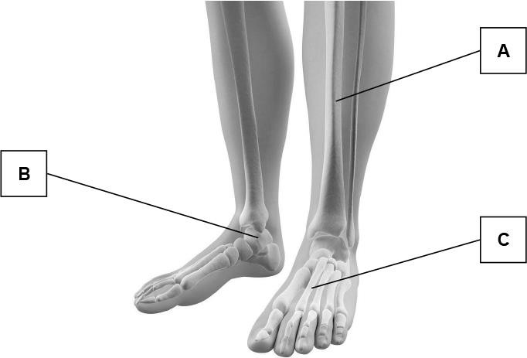
Fig.11.1

Identify A, B and C on the diagram.

A |  | [1]
B |  | [1]
C |  | [1]

- Fig. 11 shows a diagram of the skeleton.

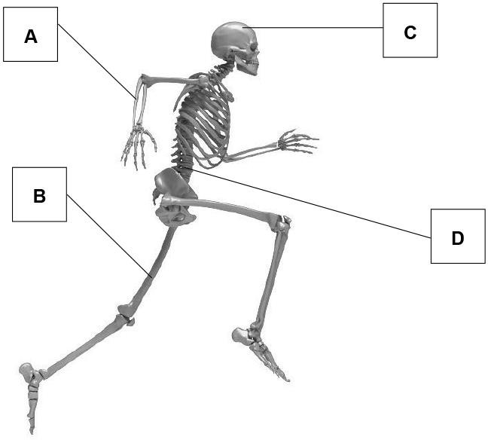
Fig. 11

State the type of bone and identify one function of each of B and D. B

D

[4]
4. Fig. 13.1 shows a diagram of a synovial joint.

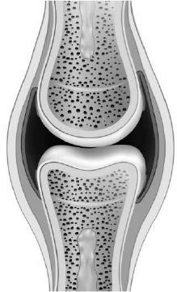
Fig. 13.1

Identify two structures of the joint and explain their functions.

[4]

- Which one of the following is a characteristic of slow twitch muscle fibres?

(a) | Few capillaries
(b) | High phosphocreatine stores
(c) | Low myoglobin stores
(d) | Many mitochondria

[1]

- A cyclist will use all three muscle fibre types at different times during a race.

State which muscle fibre type would be used in the following stages of a race:
During a long hill
climb

Maintaining a steady pace mid-race

Sprinting for the finish
line

[3]

- The following paragraph describes the structure and function of fast glycolytic fibres.

Complete the paragraph by selecting words from the box below.

Fewer | High | Weak | Strong | Many | Large | Small | Low

Fast twitch glycolytic fibres are used in activities that are intensity  and require a  very force of contraction. This is because the size of the motor  neurone is .................... and there are fibres per motor unit. | [4]

Fig. 16.1 shows a diagram of the heart.

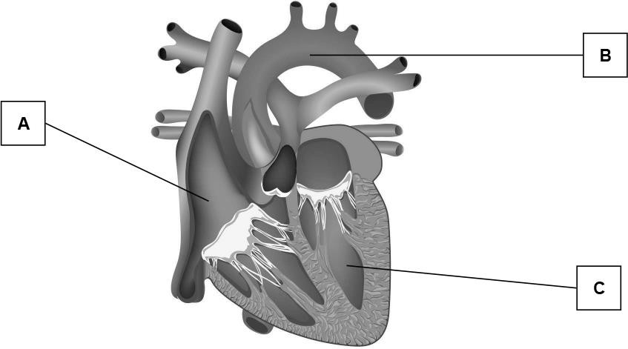

Identify A, B and C and describe the role of each in the circulation of blood.

A
Description
B
Description

C
Description

[6]

- Below are listed four components of blood. Which component fights infections? Put a tick (✓) in the box next to the correct answer.
Red blood cells
White blood cells
Platelets
Plasma
[1]


Describe the path of a drop of blood as it travels from the right atrium through the heart and around the body until it returns to the right atrium.

Your answer should include:

  - structures of the heart
  - the different blood vessels the blood passes through
  - the changes to the blood during its journey.

[10]

- Complete the table below to show the components and functions of blood.
Component | Function
 | Transport oxygen
Platelets
White blood cells
 | Fluid that transports nutrients and blood cells
[4]

- Which one of the following is the correct term for the volume of blood ejected from the left ventricle per beat?
(a) | Tidal volume | 
(b) | Stroke volume
(c) | Stroke output
(d) | Cardiac output
[1]

- Which one of the following is the correct order of respiratory passages that air would pass through during expiration?
(a) | Bronchi – trachea – nasal cavity – epiglottis
(b) | Bronchi – alveoli – bronchioles – epiglottis

(c) | Bronchioles – trachea – epiglottis – larynx
(d) | Bronchioles – bronchi – trachea – larynx
[1]

- Explain the mechanics of breathing during inspiration using the following terms:

External intercostals | diaphragm | rib cage | thoracic cavity | pressure

[5]

- Describe gaseous exchange at the alveoli by filling in the missing words below:

In the alveoli the partial pressure of oxygen is and the partial
pressure of carbon dioxide is , whereas in the blood capillaries at the alveoli
the partial pressure of oxygen is and the partial pressure of carbon dioxide is
.................... . Gases move from areas of .................... to pressure. Therefore
.................... diffuses into the alveoli and diffuses into the capillaries
surrounding them.
[8]

- Fig. 19 shows a diagram of the lungs.

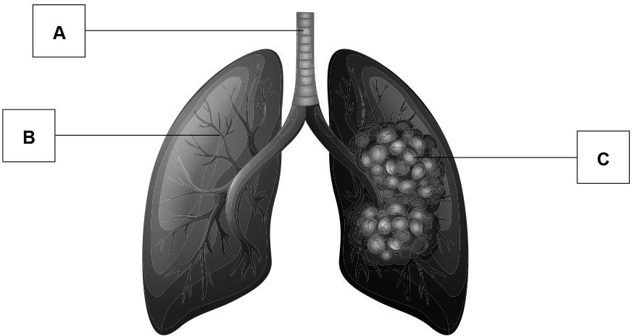
Fig. 19

Identify the structures labelled A, B and C. A
B

C

[3]

- Explain the role of the external intercostal muscles during the mechanics of breathing.

[4]

18(a). Fig. 4 shows an example of the energy continuum with three sporting activities indicated.

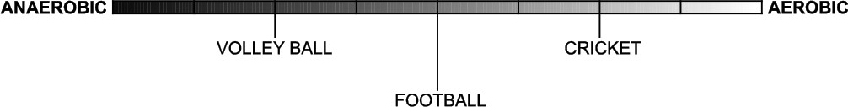
Fig. 4

Show your knowledge of energy systems by placing the following athletics events accurately on the continuum above.

A | Marathon
B | Shot put
C | 1500 m race

[3]

(b). Justify your placement of each event on the continuum.

Marathon
Shot put
1500 m
race
[3]

19. Which one of the following is the correct definition of tidal volume?
(a) | The volume of oxygen inspired per breath
(b) | The volume of carbon dioxide expired per breath
(c) | The volume of air inspired per breath

(d) | The volume of air inspired per minute
[1]

END OF QUESTION paper

Mark scheme
Structure | Function
1. Cartilage | 2. Reduces friction between bones or stops bones rubbing together
3. Ligament | 4. Attaches bone to bone or stabilise joint
5. Synovial membrane | 6.  Secretes/produces/ encases synovial fluid
7. Synovial fluid | 8.  Lubricates/cushions joint or synovial fluid absorbs / breaks down debris in joint.

Question |  |  | Answer/Indicative content | Marks | Guidance
1 |  |  | Long bone | 1
 |  |  | Total | 1
2 |  |  | - A = Tibia  - B = Talus  - C = Metatarsal | 3 | Do not accept:  A = Fibia / tibula (NBD) C = Metatarples (NBD)  Examiner’s Comments  Very few candidates scored the full three marks available for this question. Many could identify the Tibia and Metatarsals but most struggled with labelling the Talus –  with many simply writing ‘ankle bone’.
 |  |  | Total | 3
3 |  |  | - B = Long (bone)  - (Function of femur) movement / support / blood (cell) production / mineral storage  - D = Irregular (bone)  - (Function of lumbar vertebra) movement / support / protection | 4 | Candidate can get function of each bone correct even if type or name of bone is wrong.  Mark the first function given for each bone Do not accept stability = NBD  Examiner’s Comments  A high percentage of candidates found success on this question, for both the type and function of the bone.
 |  |  | Total | 4
4 |  |  |  | 4 | - Mark first two structures only.  - Function must relate to the named structure.  Examiner’s Comments  This was generally a well–answered question. The diagram showed a synovial joint and learners were expected to identify two of the structures and explain their functions. The majority of learners were able to identify the synovial membrane and the synovial fluid, with some learners identifying other structures such as the cartilage or ligament. Most who gave the correct identification then went on to accurately explain the function of each. Some learners however did not give a function for each and therefore could not score full marks. Again, it is important for learners to address all aspects of each question to have access to all the marks available.

 |  |  | Total | 4
5 |  |  | (d) Many mitochondria | 1 | Examiner’s Comments  A very small minority did not respond to one or more of these, with most answering them well. The most challenging part was that some learners unaware of the  characteristics of slow twitch muscle fibres.
 |  |  | Total | 1
6 |  |  | - Fast oxidative or Type 2a  - Slow (oxidative) or Type 1  - Fast glycolytic or Type 2b | 3 | Do not accept:  Fast or fast twitch for 1 or 3 Slow glycolytic = BOD  Examiner’s Comments  This question was to identify the appropriate muscle fibre type and it proved very difficult for many to score the full three marks available. Many were unable to identify fast oxidative or slow oxidative, but most were able to give fast glycolytic for the third answer. Simply writing fast twitch was not good enough to score marks for this Level  3 examination.
 |  |  | Total | 3
7 |  |  | Fast twitch glycolytic fibres are used in activities that are of  (1) high intensity and require a very (2) strong force of contraction. This is because the size of the motor neurone is  (3) large and there are (4) many fibres per motor unit. | 4 | Examiner’s Comments  Many learners scored the full four marks available for this question, showing a good understanding of the structure and function of the fast glycolytic fibres. There were a number of scripts where this question was left  unanswered.
 |  |  | Total | 4
8 |  |  | - A = Right atrium  - Receives (de-oxygenated) blood from body or pumps/transports / sends (de-oxygenated) blood into right ventricle  - B = Aorta  - Carries (oxygenated) blood (from L ventricle) to tissues/body/muscle | 6 | Identification must be correct for mark to be given for description. ie - If identification incorrect then mark cannot also be given for description  Do not accept:  - Pumps blood (NBD Pt6)
9.  Meniscus/menisci | 10. Additional cartilage to stabilise joint
11. Pads of fat | 12. Absorb shock or fill large spaces in joint
13. Bursa | 14. Reduce friction between tissues
15. Joint capsule | 16. Encloses joint

 |  |  | - C = Left ventricle  - Pumps/transports/sends (oxygenated) blood out of the heart/to body/into aorta |  | Examiner’s Comments  Although most could identify the structures of the heart, many were unable to back each up with an accurate description of the role of each structure. The role has to identify where the blood has come from or where it was  going to and some left this important information out.
 |  |  | Total | 6
9 |  |  | White blood cells | 1
 |  |  | Total | 1
10 |  |  | - Blood (enters right atrium) from vena(e) cava(e)  - Blood is de–oxygenated  - Blood is carrying CO2  - Under low pressure or low speed  - Blood moves into right ventricle  - Through tricuspid valve  - Opened by weight of blood  - Right atrium contracts  - Overfilling of right ventricle  - Right ventricle contracts  - Tricuspid valve closes to prevent backflow of blood  - Blood moves into pulmonary artery  - Through pulmonary valve  - Valve closes to prevent backflow  - Blood travels to lungs/alveoli  - Through arterioles  - To capillaries  - Gaseous exchange/diffusion  - Blood is (re–)oxygenated / oxygen enters blood  - CO2 is removed  - External respiration  - Oxygen picked up by red blood cells  - Blood moves into pulmonary vein  - Through venules/veins merge together  - Blood enters left atrium  - Very low pressure  - Blood moves into left ventricle  - Through bicuspid/mitral valve  - Left atrium contracts  - Stretching/overfilling left ventricle | 10 | Level 3 (8–10 marks)  A comprehensive answer:  Detailed knowledge & understanding. Effective analysis/critical evaluation and/or discussion/explanation/development.  Clear and consistent practical application of knowledge. Accurate use of technical and specialist vocabulary.  High standard of written communication.  At Level 3 responses are likely to include: Detailed knowledge and understanding of the double circulatory system.  Most points are developed.  At the top of this level chambers, heart valves and most blood vessels are identified in the correct order. Changes to blood are covered.  At the bottom of this level some heart valves may be omitted but blood vessels and chambers of heart are in correct order and changes in blood gases are probably considered.  Level 2 (5–7 marks) A competent answer:  Satisfactory knowledge & understanding. Analysis/critical evaluation and/or discussion/explanation/development attempted with some success.  Some success in practical application of knowledge. Technical and specialist vocabulary used with some accuracy.  Written communication generally fluent with few errors.  At Level 2 responses are likely to include: Satisfactory knowledge and understanding of the movement of blood through the circulatory system. Points made but generally not developed.  At the top of this level most chambers and blood vessels are covered in the correct order. An attempt to explain changes in blood gases may be made and at least one  heart valve is correctly identified.

 |  |  | - Left ventricle contracts  - Bicuspid/mitral valve closes to prevent backflow into left atrium  - Blood is pumped into aorta/aortic arch  - Through aortic valve  - At very high pressure/speed  - Blood travels to tissues/muscle (accept named muscle)  - Through arteries  - Into arterioles  - Into capillaries  - Blood pressure/speed is reduced  - Gaseous exchange/diffusion  - O2 passes into tissues  - CO2 enters blood  - Internal respiration  - Blood passes into veins  - Via venules  - Blood is now de–oxygenated  - Blood is at very low pressure/increasing speed  - Valves prevent backflow  - Blood re–enters right atrium via vena(e) cava(e)  - Inferior/superior vena cava  - For blood returning from below/above heart  - Venous return mechanisms / skeletal  muscle pump / respiratory pump  - Double circulatory system  - Pulmonary circuit (to lungs)  - Systemic circuit (to muscles/tissues) |  | At the bottom of this level chambers and blood vessels are covered but there may be some errors. Oxygenated / deoxygenated blood / gaseous exchange has been mentioned at some point.  Level 1 (1–4 marks) A limited answer:  Basic knowledge & understanding.  Little or no attempt to analyse/critically evaluate and/or discuss/explain/develop.  Little or no attempt at practical application of knowledge. Technical and specialist vocabulary used with limited success.  Written communication lacks fluency and there will be errors, some of which may be intrusive.  At Level 1 responses are likely to include:  Basic knowledge of the movement of blood through the circulatory system.  At the top of this level at least 2 chambers of heart and arteries, capillaries and veins are mentioned, but if order of chambers/blood vessels are incorrect then max of 3 marks.  To score 1 mark one blood vessel, gaseous exchange or a ventricle has been mentioned.  [0 marks] No response or no response worthy of credit.  Examiner’s Comments  This ten–mark question is marked using a levels response mark scheme; examiners use the levels descriptors and indicative content in the mark scheme to reach a holistic judgment about the level within which the response should sit and award a mark within that level accordingly.  As with the January series, many learners partially answered this question well but did not fully address all aspects. Learners are again reminded that all the variables in the question are taken into consideration when awarding a mark for a particular response.  As with the January series, many learners partially answered this question well but did not fully address all aspects. Learners are again reminded that all the variables in the question are taken into consideration when awarding a mark for a particular response.  Those learners who took into consideration all these elements and accurately described the path of blood scored very well – with some able to score the full ten  marks available. Those who were less accurate or were

confused in their description or who left out one or more of the aspects scored less well. Some learners started with a short plan or diagram to help them focus in on the path of the blood and this seemed to help then in describing the path of blood more accurately.

Some marks were given to learners even where the path of blood was incorrect if they had shown knowledge of structures, but they could rarely access more than three marks unless most of the path of the blood was accurately described.

Some learners who showed the very best answers went into fantastic detail concerning gas exchange and the structures of blood vessels.

This extended question is also assessed on the quality of written communication and the better responses showed a fluent and accurate response with few spelling errors and with good use of clear sentences and paragraphs.
More limited responses showed weaker accuracy in spelling, used technical terminology less effectively and rarely structured their answer. Centres are advised that learners should be given more guidance and feedback on the quality of their written communication so that they are better able to write clearly and fluently for this extended
question.
 |  |  | Total |  |  |  | 10
11 |  |  |  |  |  |  | 4 | Correct answers are in bold and underlined  (WBC) Produces antibodies = BOD  (Platelets) Stops bleeding / heals the wound= NBD  (WBC) Helps infections/ fights illness = NBD  (WBC) Ingest pathogens / engulfs pathogens/ fights
11 |  |  |  | Component | Function |  | 4
 |  |  |  | Red blood cells | Transport oxygen |  | 4
 |  |  |  | Platelets | Help blood to clot |  | 4

pathogens = BOD

Examiner’s Comments

A high number of candidates successfully completed the table shown in the question, normally attracting 3-4 marks. Red blood cells and plasma were more consistently correct with points generally being dropped due to poor wording or incorrect functions that could not
be awarded a mark, normally for the function of platelets.
 |  |  | Total | 4
12 |  |  | (b) - Stroke volume | 1
 |  |  | Total | 1
13 |  |  | (d) Bronchioles – bronchi – trachea - larynx | 1 | Examiner’s Comments  A very small minority did not respond to one or more of these, with most answering them well.  Candidates advised to read question and all answers carefully before committing to a particular answer.  Candidates are advised to look for and/or highlight key words in each question.  Candidates should beware of a negative question e.g. which is not a ... and lung volumes relate to air, not oxygen. Candidates are also reminded to be aware of and to recognise the specific muscles within the quadriceps and hamstrings.  Candidates are also advised to re-visit these multi-choice questions again if they have time.  Very few scored 10/10 for the multi-choice section.
 |  |  | Total | 1
14 |  |  | - External intercostals contract  - Diaphragm contracts/flattens  - Rib cage moves up/out  - Volume of thoracic cavity increases  - Pressure in lungs is reduced | 5 | Candidates may write a sentence using more than one word.  E.g. external intercostals and diaphragm contract = 2 marks.  E.g. Rib cage moves up, increasing volume of thoracic cavity and decreasing pressure inside lungs = 3 marks.  Do not accept:  - Diaphragm moves up  - Makes lungs larger
White blood cells | Protect against/fight disease/infection
Plasma | Fluid that transports nutrients and blood cells

Examiner’s Comments

Candidates that fully explained the mechanics of breathing during inspiration, using all the terms available in the ‘word bank, scored well. Too many candidates got themselves confused with the mechanics of inspiration with the mechanics of expiration and so scored few marks. Those that scored marks explained the roles of the diaphragm, external intercostals and the ribs and it was only the most able candidates who were able to effectively explain the role of the thoracic cavity and
pressure.
 |  |  | Total | 5
15 |  |  | In the alveoli the partial pressure of oxygen is high and the partial pressure of carbon dioxide is low, whereas in the blood capillaries at the alveoli the partial pressure of oxygen is low and the partial pressure of carbon dioxide is high.  Gases move from areas of high to low pressure. Therefore, carbon dioxide diffuses into the alveoli and oxygen diffuses into the capillaries surrounding them. | 8 | Answers are in bold and underlined. Order of answers is:  High - low – low – high – high – low – CO2 – O2  Accept alternative valid words for high/low e.g. great/small, increased/decreased  Examiner’s Comments  This was generally well-answered, with most candidates scoring at least two marks. Those that did not score full marks often got the last sentence wrong with the actions  of carbon dioxide and oxygen the wrong way around.
 |  |  | Total | 8
16 |  |  | A = trachea  B = bronchiole  C = alveolus/alveoli/alveolar sac | 3 | Examiner’s Comments  The majority of candidates successfully labelled all 3 structures. Trachea was generally correct for A. B was often highlighted as bronchus or bronchi instead of  bronchioles. C was generally correct.
 |  |  | Total | 3
17 |  |  | - Contract during inspiration/breathing in  - Causing ribs to move up/out  - To increase volume/size of lungs/thoracic cavity  - To reduce pressure in lungs/thoracic cavity  - Relax during expiration/breathing out  - Causing ribs to move down/in  - To decrease volume/size of lungs/thoracic cavity  - To increase pressure in lungs/thoracic cavity | 4 | Sub-max 3 for inspiration  Sub-max 3 for expiration  Increase / decrease size of chest = NBD  Examiner’s Comments  The mechanics of breathing has traditionally been the  ‘Achilles heel’ for candidates who have often tied themselves up into knots trying to explain this topic area.

Answers this examination series brought a breath of fresh air – with many scoring the full 4 marks. There are still too many candidates mixing up the mechanics for inspiration with expiration and vice versa. Some gave answers which made it unclear whether the mechanics belonged to inspiration or expiration. It is important that candidates identify for the examiner which explanation
refers to inspiration and which for expiration.
 |  |  | Total | 4
18 | a |  | - Marathon must be near to aerobic end of continuum  - Shot put must be at the anaerobic end of continuum  - 1500m must be in central third of continuum | 3 | Marathon does have some anaerobic elements.
 | b |  | - Marathon an endurance event/low intensity/long duration  Shot put involves (explosive)  - strength/power/speed/high intensity/short duration  1500 m race has elements of  - speed/muscular endurance and lower intensity/lasts more than  three minutes | 3 | For 1500 m answer must cover both aerobic and anaerobic elements.  NB. Do not accept use of ‘aerobic/anaerobic’ for justification, e.g. Marathon is an aerobic event.
 |  |  | Total | 6
19 |  |  | (c) The volume of air inspired per breath | 1 | Examiner’s Comments  A very small minority did not respond to one or more of these, with most answering them well. This question proved to be a most challenging question.  Candidates advised to read question and all answers carefully before committing to a particular answer.  Candidates are advised to look for and/or highlight key words in each question.  Candidates should beware of a negative question e.g. which is not a ... and lung volumes relate to air, not oxygen. Candidates are also reminded to be aware of and to recognise the specific muscles within the quadriceps and hamstrings.  Candidates are also advised to re-visit these multi-choice questions again if they have time.  Very few scored 10/10 for the multi-choice section.

 |  |  | Total | 1

Movement analysis
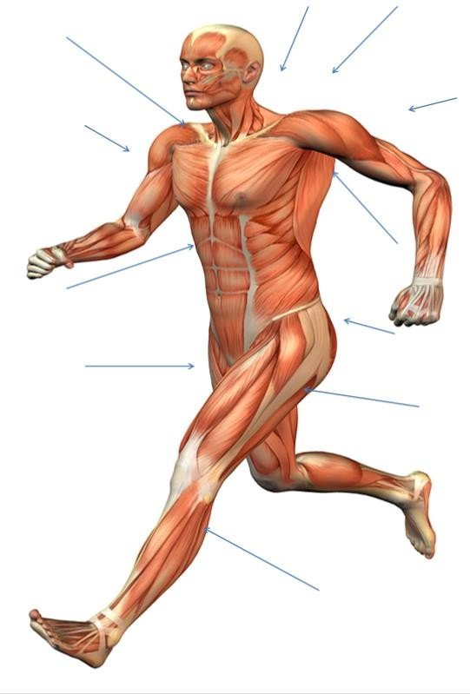
Using the diagram identify as many major muscles as you can. There are 11 here but can you challenge yourself and label more?

The Structure and Function of the Muscular System

Types of muscle functions

Key words that you need to know:

- Antagonistic Pairs – where muscles work together to produce movement, with one muscle contracting (agonist) and the other relaxing (antagonist)
- Agonist – the prime mover; the muscle that contracts and shortens

- Antagonist – the muscle that relaxes and lengthens

- Fixator – stabilises the joint and assists the agonist with movement

Fill in the missing words
Movement | Agonist | Antagonist | Fixator
Flexion at elbow | Bicep |  | Trapezius
Extension at elbow |  |  | Trapezius
Flexion at knee | Hamstring |  | Gluteal
Extension at knee |  |  | Gluteal
Abduction at shoulder |  | Latissimus Dorsi | Trapezius
Adduction at shoulder |  | Deltoid | Trapezius
Plantarflexion | Gastrocnemius | Tibialis Anterior
Extension at hip | Gluteals | Illiopsoas

Annotate each of the diagrams analysing each movement phase for a sporting action. Explain in as much detail as possible for each movement.
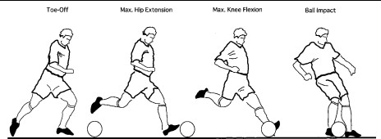
What type of movement is occurring at each joint? E.g Phase 1 Hip joint is extended as the performer takes their leg back to strike the ball. -Phase 2 Flexion at the knee takes their lower leg back to generate power. Can you name any of the muscles involved?

Steph Curry shooting a 3 pointer in basketball. Annotate each phase to analyse this sporting action.
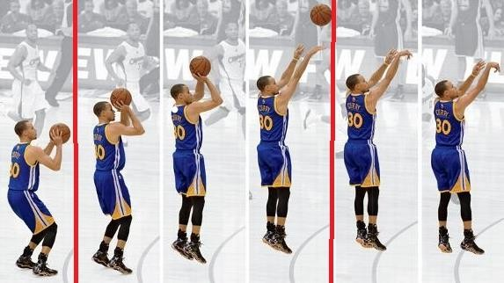

A fast bowler in cricket. Annotate each phase to analyse this sporting action.
