
A Level Photography & Visual Media
Home Learning Pack
Challenges

Please find attached a pack of work to help prepare you for Sixth Form.

I am delighted that you have shown an interest in A Level Photography. In order to get you thinking about the subject, I have drawn up a challenge pack to help you prepare for studies in the 6th form such as photography research activities, books to read, films to watch on a rainy afternoon, useful websites to browse when Snapchat and Instagram get dull.

For a look at the syllabus:
A Level Photography As / A2 Studies Specification
https://www.eduqas.co.uk/ed/qualifications/art-and-design-as-a-level/#tab_overview
(Subject to change)

Useful websites/apps- register now:
- Use Pinterest
- https://thephotographersgallery.org.uk/
- For (Art & Photography) news stories use the BBC website
- http://news.bbc.co.uk

Please email me nmurray@woolwichpolyboys.co.uk if you have any queries or questions.

In the meantime, I want to say a big thank you for your hard work at Woolwich Poly or at a previous school and I am so very sorry you have lost your opportunity to complete the exams. During these unprecedented times it’s important to keep going and know we will be back to normal soon.

Kind regards,

Ms. N Murray
Lead Photography Teacher
Woolwich Polytechnic Sixth Form

CONTENTS

- Home Learning Activities Challenges
- A week in Photography
- Different types of Photography
- Famous Photographers
- iPhone Challenge- become an investigative photographer

- Reading
- Newspapers and magazines
- Websites

- Films

- Key Genres / Terms/ Skills/ About the course

- Reading advice for the PI essay

Home Activities

A week in pictures is your starting point. You could choose 7 different days from 7 different years or significant periods for you and your life/ family life or in history, you don’t have to go with the obvious, please think outside the box.
My choices (a random example of images that stood out to me, the first was when I was 8 years old, I remember seeing the Challenger explode on the TV in front of my eyes and I was really upset because we had been following this in school as there were lay people being given the chance to go into space, one was a teacher. )  Tuesday, January 28, 1986  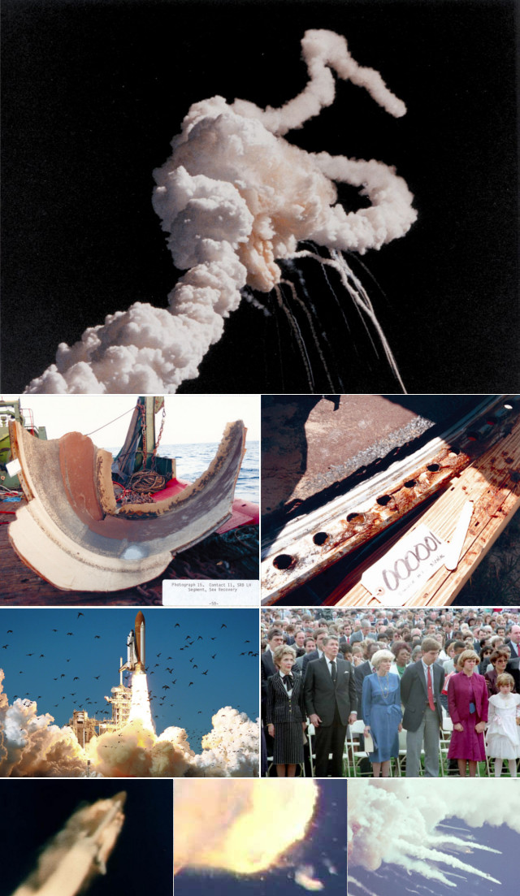  Read more: https://en.wikipedia.org/wiki/Space_Shuttle_Challenger_disaster | Your instructions/ tasks:  1. Select 7 pictures, this could be one for each day (do not worry if the days don’t completely correspond, that is not the point of the exercise). The images should represent the POWER OF IMAGERY in a news story, politics, music, popular culture, something personal to you, or something you remember and the photograph stays in your head. It could also be a photograph that really speaks to you from the past.  The best websites for this sort of thing come from engaging news-stories and Photojournalists, see if there is something different happening, not just Coronavirus.  For example:  https://www.theguardian.com/inpictures  http://100photos.time.com/  https://www.magnumphotos.com/  www.wikipedia.org  www.newscinetist.com  www.nationalgeographic.com  www.magnumphotos.com  Another website you use for pictures can also be Pinterest/ Instagram.  Save these and create a Google Docs presentation/Powerpoint presentation. Fill a slide up with all the images (and some extras that you like). Take each image and add to a slide. (7 slides representing each day).
Wednesday  I grew up in Northern Ireland during the troubles so these scenes are part of my memory bank, seems like another world away now and I am relieved that we have moved on, but like all bad memories and dreams, we should learn from our mistakes.  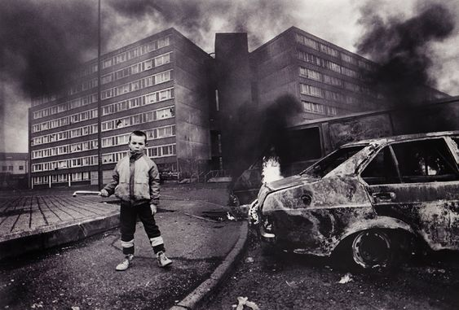  Belfast -The notorious Divis Flats complex is now all demolished except the Divis Tower, it was a heavy duty Republican stronghold with serious IRA activity. The first child to die in the troubles died here, 9 year old Patrick Rooney. During the height of the troubles the British Army put an'Spy Post' on the roof of Divis Tower the tallest building but the area was so dangerous the soldiers could only be resupplied by helicopter there was no way they could come down the stairs. | 2. For each picture, write a commentary/explanation:  - What is/ was happening  - What has it got to do with Photography?  - Find out where & when it was taken?  - What was the context? Why was it taken?  - Who took it?  - Why have you chosen to include it in your week of pictures?  - Write this down in a paragraph beside each image
Thursday  New York, 2003. Annie Leibovitz Photographs Band the White Stripes. This images stands out as Annie Leibovitz is one of my favourite female photographers and this was a huge image I got to see in person at her retrospective a few years back. The White Stripes are a great band too and I am a big fan of music photography. 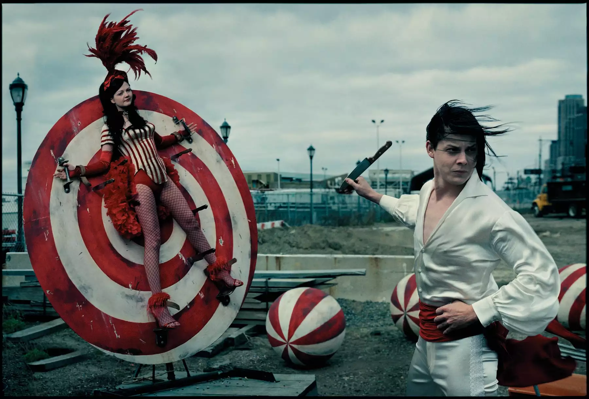 | 3. Select the picture that tells you a story that you found most interesting. Why was this?
4.Create an interesting presentation showing your pictures

email it to
nmurray@woolwichpoly.co.uk

Research Activity

Task:
Present your information as a report, PowerPoint presentation or poster.

Guess the category of photography from the pictures below and research it! Write the category in the box next to the picture. Add information and images relating to the image to demonstrate your understanding of the category. Explain the use of it and HOW it relates to PHOTOGRAPHY (See over to next page for the categories)

 | 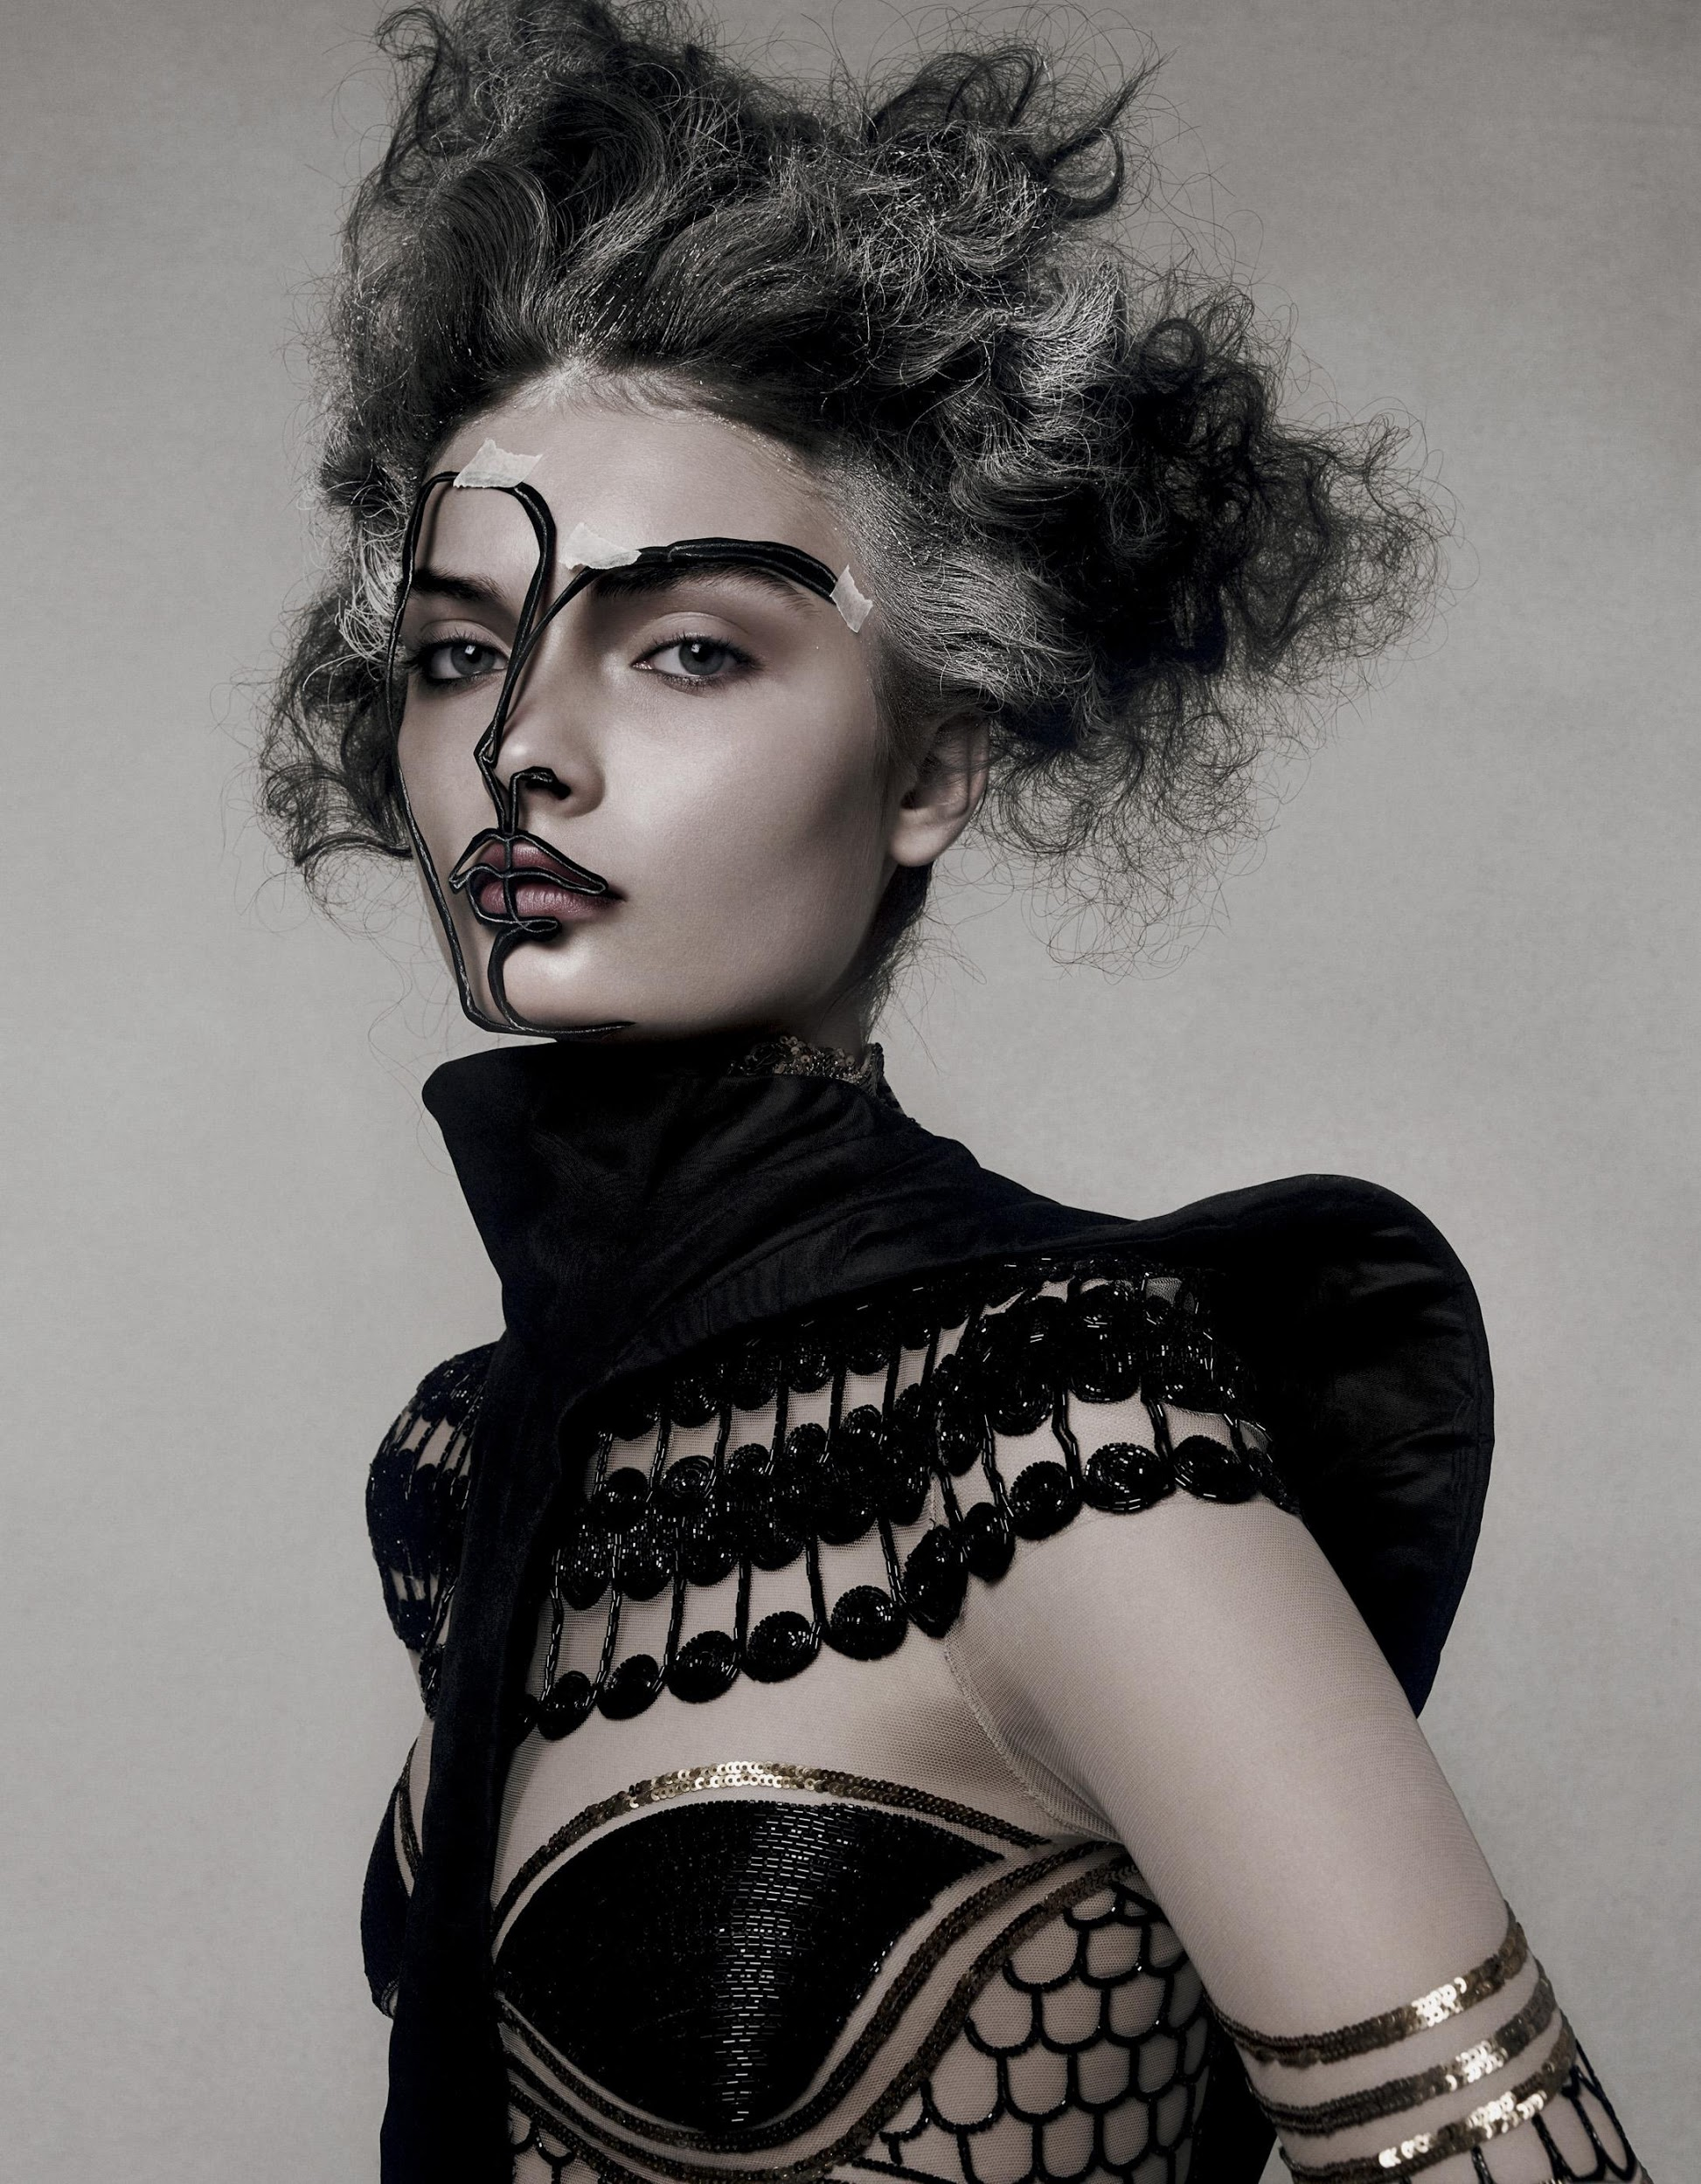 | 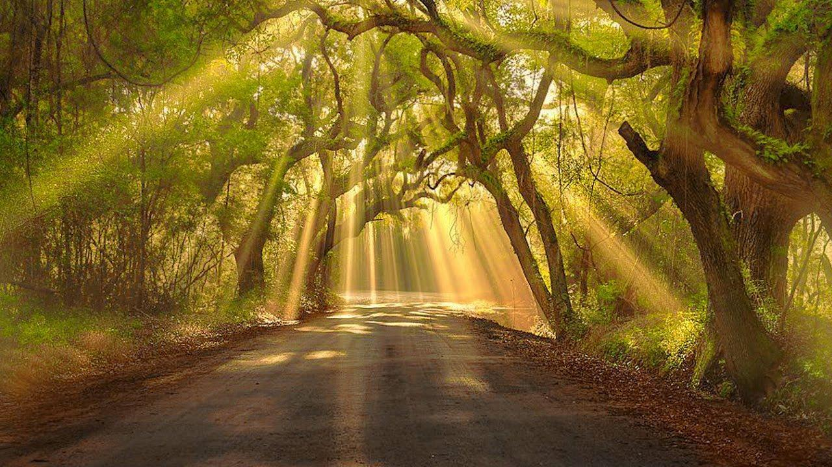
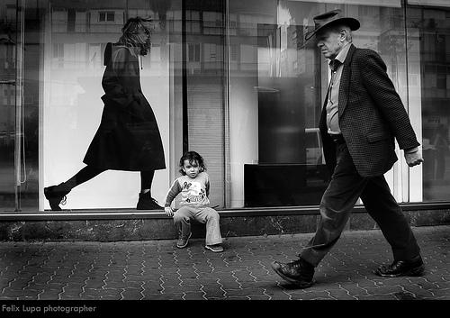 |  | 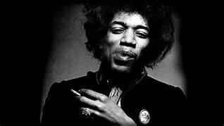
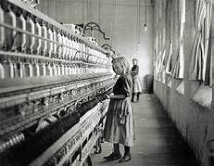 | 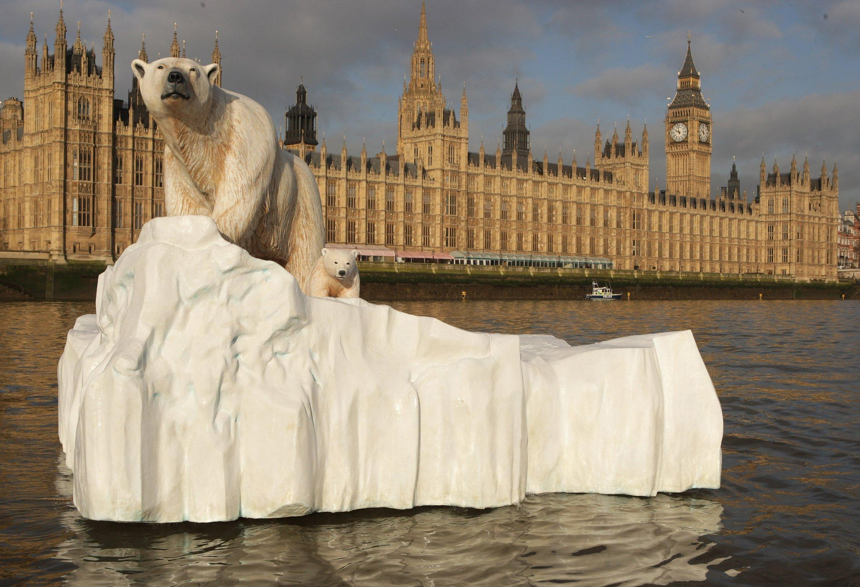 | 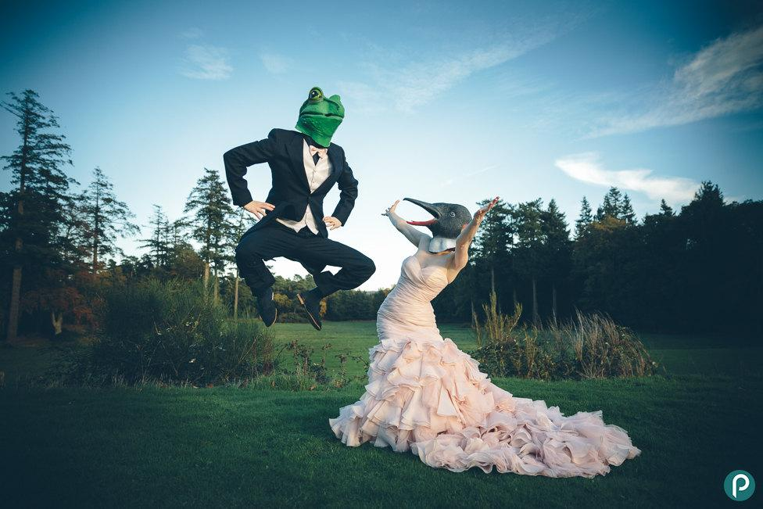
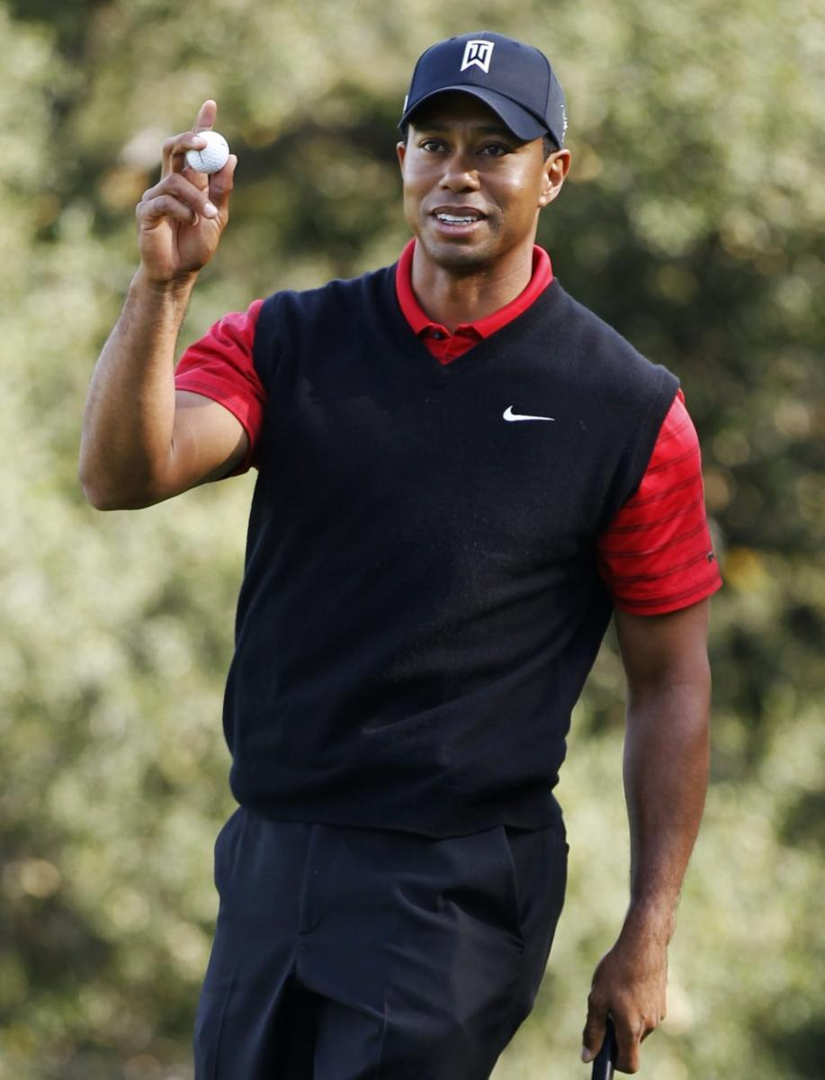 | 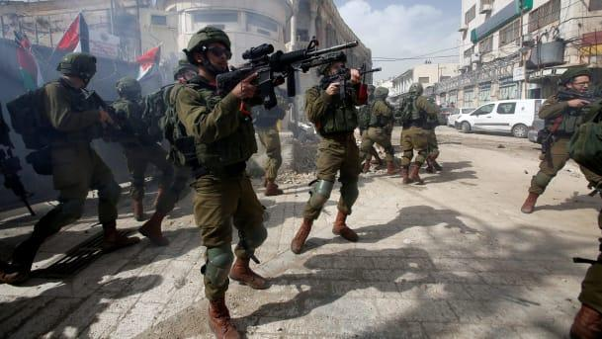 | 

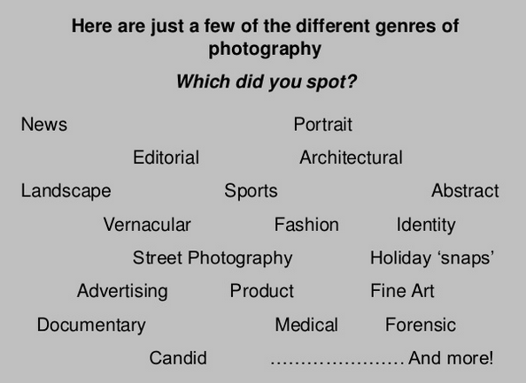
Leading Photographers throughout time
Task: Research these photographers briefly

1. Jimmy Nelson  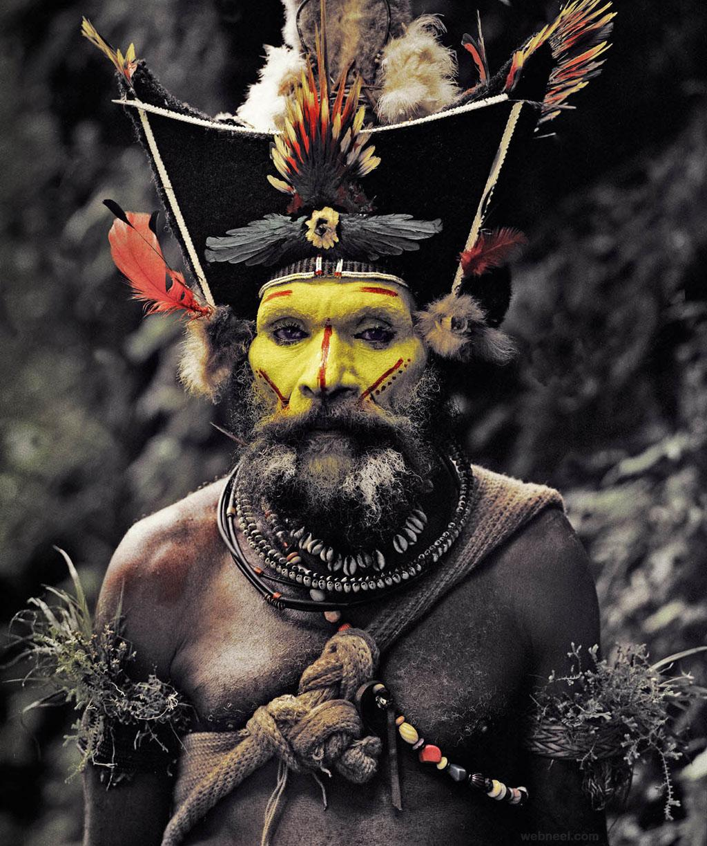 | 2. Mario Testino  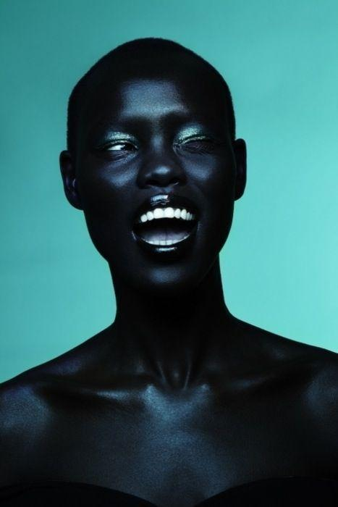 | 3. Annie Leibovitz  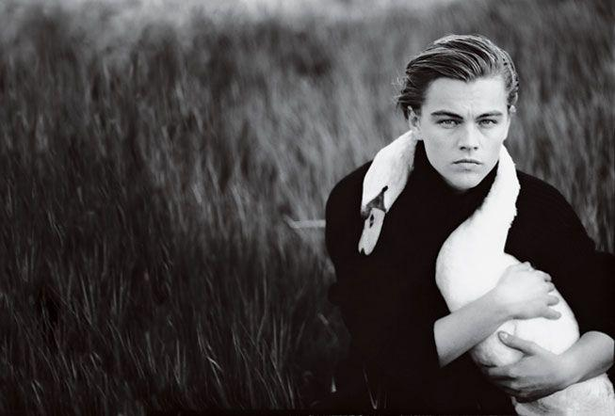
4. Diane Arbus  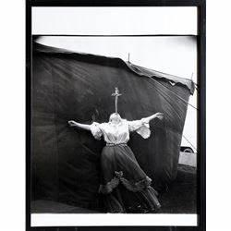 | 5. Timothy Hogan   | 6. Henri Cartier Bresson  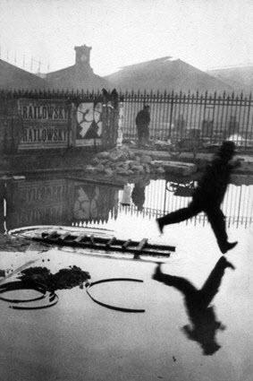

Research these different photographers and find out the following: -
- What have they done?
- Why are they famous?
- How did they do it?
- What is their net worth?
- What makes them special?

Research Activity
One of the first things we do in the A Level lessons is to create a crime scene for you to photograph, where you get to be like a CSI investigator. We based this on the following documentary about JonBenét Ramsey, the child beauty pageant queen who was tragically murdered.


https://www.youtube.com/watch?v=-KMEOaMCJss&feature=youtu.be

Feel free to watch the trailer or find the documentary on Netflix. (Warning, sensitive material to some of you- check the age restrictions)

Research Photographer Sophie Calle who uses a ‘voyeuristic’ investigative style in her ‘Hotel ‘ series of photography.

Present your information as a report, PowerPoint presentation or poster. Include images.

- Research Photographer Sophie Calle-’Hotel’ Series. You can watch a small clip about her here
- https://youtu.be/V5yLOcp-azI

- You can find a great link here with information on some of the works: https://www.tate.org.uk/art/artworks/calle-the-hotel-room-47-p78300

- Research some basic facts: (See section 6 to help you with your writing before you begin)

- Research the term Formal Elements. Write the meaning and add it to your presentation
- Research the term factual documentation
- Research the term voyeurism
- Include 3 to 4 pictures from the photographer that you like (from her Hotel series). Add their name to a new slide on your presentation. Add some information about them. (Brief paragraph)

- Explain the following:
- What type of Photography does the Photographer specialize in / do?
- Choose ONE of the pictures and answer these questions about ONE of the images using the key terms you just researched for FORMAL ELEMENTS. Eg: the photographer uses Lines and contrast to draw the eye to the subject matter.
- Describe the picture? What can you see?
- Use the grid below to add more information in your own words about the Photographer you have chosen.
- Having studied Sophie Calle’s work, what is your personal opinion about her work?
- Do you think it is Voyeuristic in nature?
- How does it make you feel?
- Is voyeurism a crime and how do you think this term relates to the documentary about Jon Benet ?
- Do you think Sophie Calle is playing with the ‘gaze’? The female/ male gaze? Identity? Gender stereo -types?

- Developing your writing

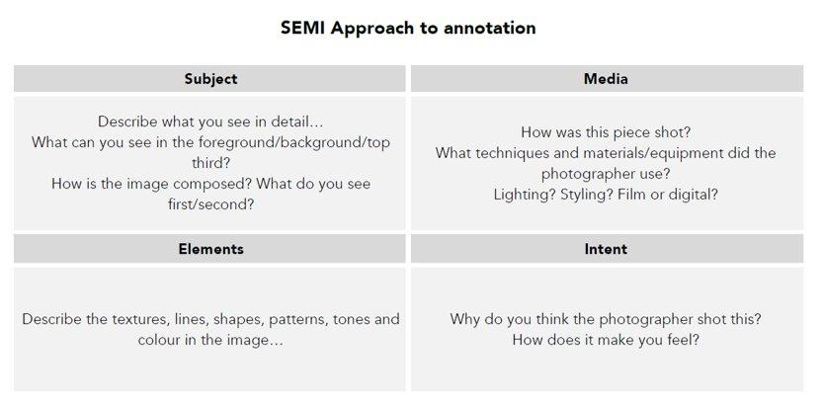

- How could you recreate this artist’s work?

Write down a few ideas for creating a shoot in this artist's style. (Photoshoot plan)

Things to include:
- Props/ models/ location/ lighting
- Any equipment or backgrounds you may use
- Any other things relevant to your photoshoot

- OPTION ONE:
Create a Portrait of your room or a room/ rooms in your home. For your photoshoot use a camera/ phone device with camera. Take a minimum of 15-20 pictures. Change it up. You can use some themes such as FORMAL ELEMENTS and you can photograph the Whole room or just details of the room in the style of Sophie Calle.
You could extend this idea by taking a ‘family portrait of your rooms’.

NB*you do not need to include any photographs of people in this work but please do ask permission before you start photographing their room :)

- When you have done add these to a slide as a CONTACT SHEET (research this is and how to do it successfully)
- Extension: In prep for starting the course you can also look at some of the other artists we will be looking at on the course.

https://woolwichpoly-my.sharepoint.com/:p:/g/personal/lcadman_woolwichpoly_co_uk/Ed0uTg3frKpEprfI9Zv38bQBzkwqYF0wTe6lCbopFyxbsg?e=4%3AUt8D1Z&at=9&CID=1556dc18-f706-6dc5-9c8d-a2f9efad7cf1

READING
Other recommended reads -
Quality newspapers/magazines such as The Times, Guardian, Telegraph, Independent, journals such as National Geographic & New Scientist.

https://www.theguardian.com/artanddesign/2012/nov/16/photography-camera-tips

https://petapixel.com/2016/09/14/20-composition-techniques-will-improve-photos/

https://photographylife.com/elements-of-composition-photography

https://improvephotography.com/1341/top-21-up-and-coming-photography-sites-to-watch-and-learn/

  https://www.dazeddigital.com/ |   www.newscinetist.com |   https://eos-magazine.com/ | 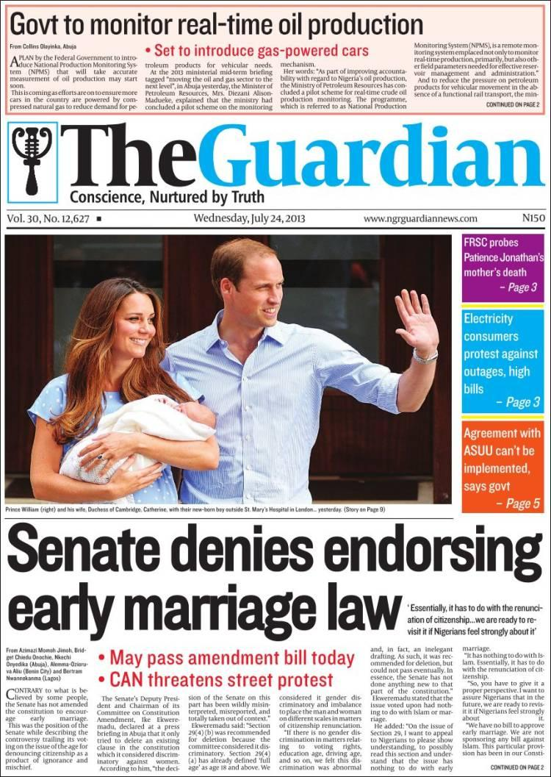https://www.theguardian.com/uk
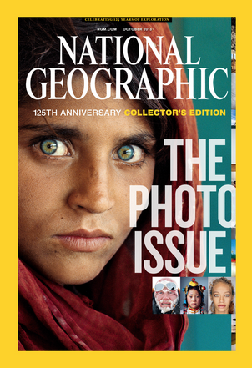  www.nationalgeographic.com |   www.huffpost.com | 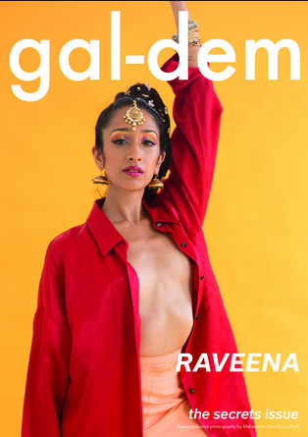  www.gal-dem.com | 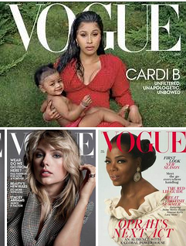  www.vogue.co.uk

FILMS
Watch something about Photographers on Netflix*

1 | Rear Window (1954)  The main character, James Stewart, stars alongside Grace Kelly in this classic Hitchcock thriller about a wheelchair bound photographer who spies on his neighbors through the lens of his camera. In one of his voyeuristic episodes he is convinced he sees one of them commit a murder.  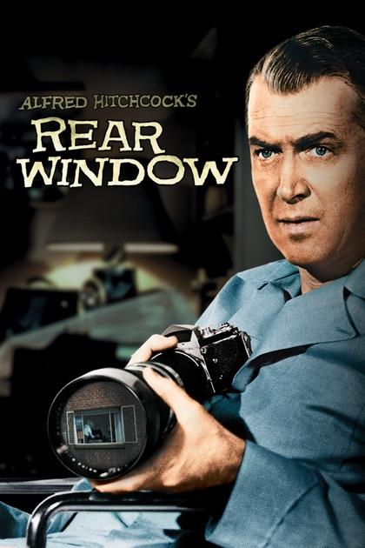
2 | Closer (2004)  Julia Roberts portrays a portrait photographer who gets entangled in a love triangle with the characters played by Jude Law and Clive Owen. Although the film only shows a little bit of the photography side, the film itself was wonderfully shot and gives an accurate depiction of the photography process.  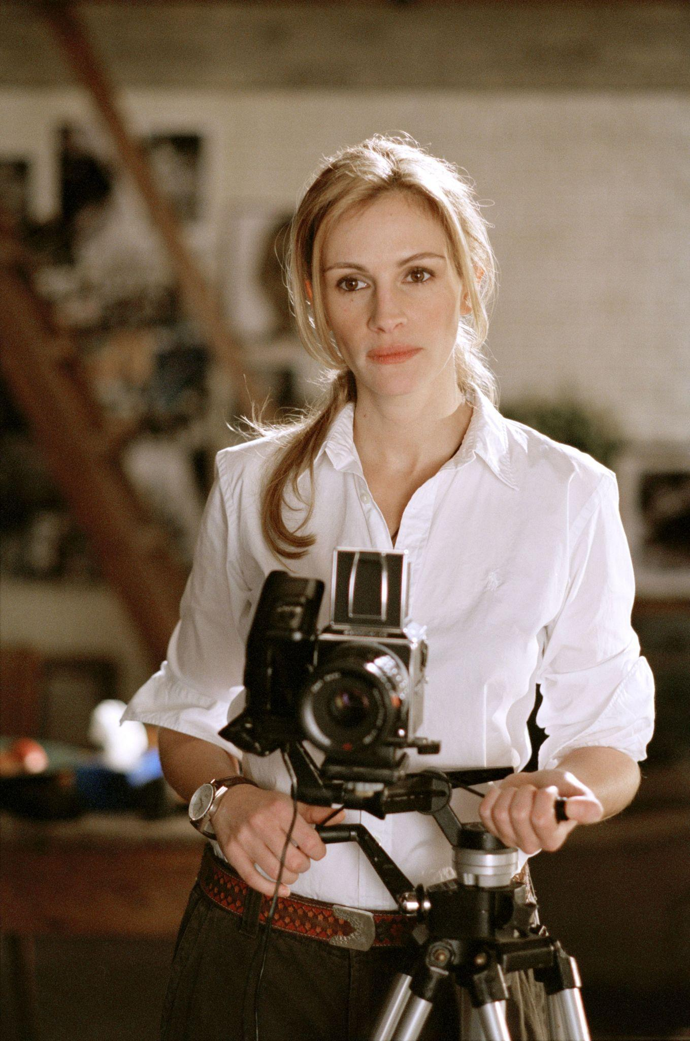
3 | Control  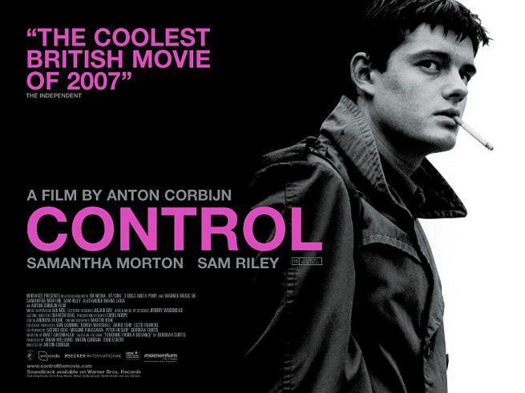
4 | City of God (2002)  This chilling portrayal of life growing up in the favelas and streets of Brazil shows two boys coming of age, one of them growing up to become a photographer. Not only considered as the best film about photography, it is also one of the best films to come out in recent years.  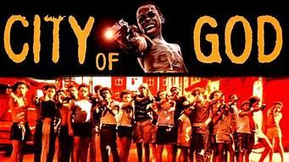
5 | Fur: An Imaginary Portrait of Diane Arbus (2006)  Nicole Kidman stars in this biopic about the legendary American photographer Diane “Fur” Arbus. The film shows how a lonely and shy housewife in New York set out a journey into the world of photography shooting images of people that stand outside the confines of society.  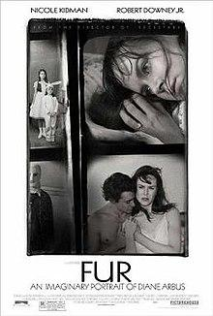
6 | The Secret Life of Walter Mitty (2013)  Ben Stiller plays Walter Mitty, a negative assets manager at Life Magazine, who ended up with an adventure of a lifetime when he sets out to find Sean O’ Connell, played by Sean Penn. after negative #25, which O’Conell describes as the “quintessence of Life”, intended to be Life Magazine’s final issue cover goes missing.  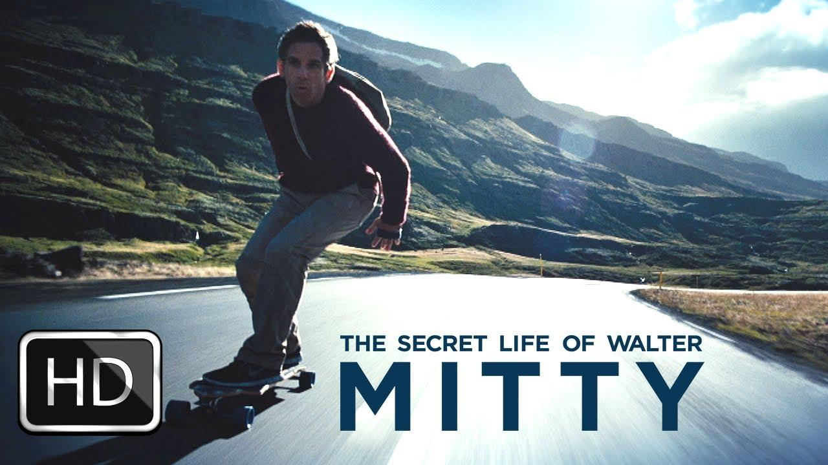
7 | Harrison’s Flowers (2000)  Andie MacDowell stars as the wife of a missing photojournalist reported lost in the Yugoslavian civil war of 1991. She teams up with two other photographers, played by Brendan Gleeson and Adrien Brody, to help her find her missing husband.  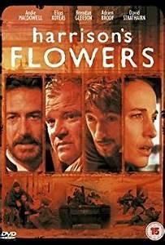
8 | War Photographer (2001)  An intimate look at the career of photojournalist James Nachtwey as he shoots his way into the horrors of world conflicts. Aside from the photography aspect of his job, viewers are taken inside the mind of Nachtwey as he searches in vain for the logic behind the brutality and cruelty of war.  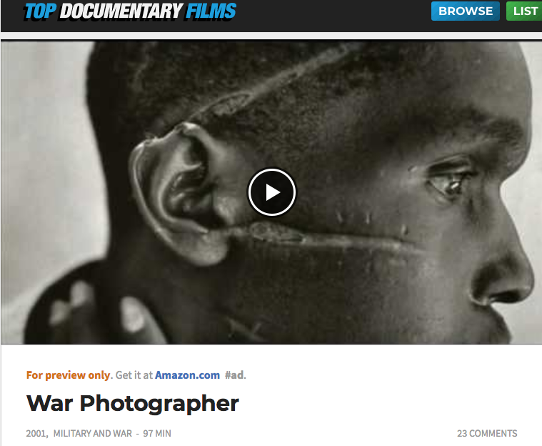

Annie Leibovitz “Life Through A Lens” (2008)
Celebrated photographer Annie Leibovitz through the eyes of some of her well known subjects such as: Whoopi Goldberg, Kirsten Dunst, Kiera Knightly, Mick Jagger and more.
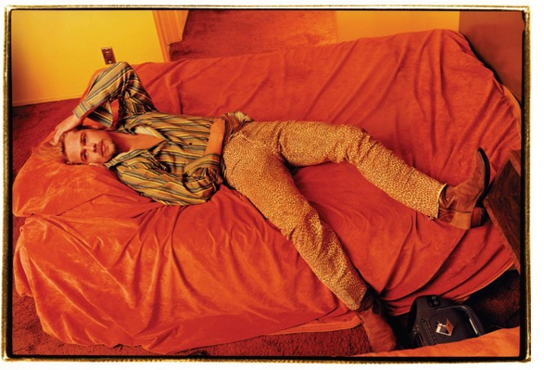

*Some of these films may include mature themes so please check the ratings before watching.

YouTube

Masters of photography:
https://www.youtube.com/channel/UCLHyRIUyTszllmLGmgNqBHw

SONY AWARDS
https://www.youtube.com/watch?v=t6XgvjpDm7E
https://www.youtube.com/watch?v=jF-C-TMQUiQ
https://www.youtube.com/watch?v=245v6Lpb4pc

Photography in general
There are LOTS of really great resources out there to show you what an A Level sketchbook looks like. Here are a few to begin with:
- https://www.youtube.com/watch?v=RUpAbZT8b-0&t=230s
- https://www.youtube.com/watch?v=RUpAbZT8b-0

What is Photography like at Woolwich Poly?

Photography is a ‘learning to look’ course. Photographers notice things. They are attuned to the intricacies of the world around them and the everyday. You will learn to use a variety of photographic tools to capture and record the way the world looks through the camera and other experimental means including video, animation and computer programming should you wish. A level photography will help you to learn to look with new eyes and will, consequently, enhance your life. We would also like to let you know that you are in very good company with a range of highly talented and enthusiastic artists, photographers who are your teachers so you’ll probably also end up with an impressive A level result and a portfolio which will stand out from the crowd.

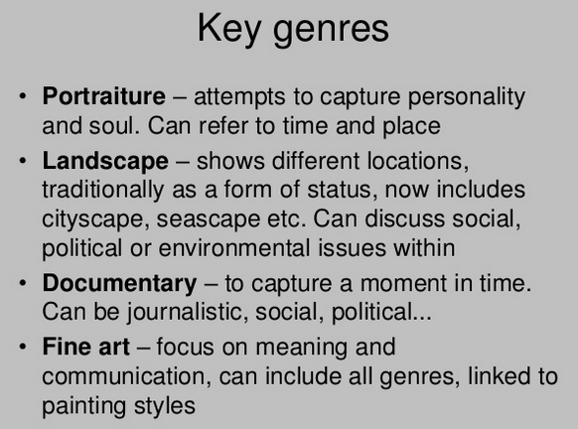

We will also look at:
- Studio lighting/ key lighting
- Portraiture
- Landscape
- Architecture
- Still Life
- Fashion
- Unusual lighting techniques
- Dark light Photography/ Drawing with light
- Experimental processes such as Cyanotype.
- Use a range of different DSLR cameras and lenses from Macro to Nifty Fifty

On this course you will develop:
- The ability to explore elements of visual language, line, form, colour, pattern and texture in the context of photography
- An awareness of intended audience or purpose for your chosen area(s) of photography
- An appreciation of viewpoint, composition, aperture, depth of field, shut-ter speed and movement
- The appropriate use of the camera, film, lenses, filters and lighting for work in their chosen area(s) of photography
- An understanding of techniques related to the production of photo-graphic images and, where appropriate, presentation and layout.
- The ability to respond to an issue, theme, concept or idea, or work to a brief or answer a need in photography

You must show knowledge and understanding of:

- Relevant materials, processes, technologies and resources
- How ideas, feelings and meanings can be conveyed and interpreted in images and artefacts created in your chosen area(s) of photography
- Historical and contemporary developments and different styles and genres
- How images and artefacts relate to social, environmental, cultural and/or ethical contexts, and to the time and place in which they were created
- Continuity and change in different styles, genres and traditions relevant to photography
- A working vocabulary and specialist terminology that is relevant to your chosen area(s) of photography.

We look forward to seeing you in September!

To find academic papers on photography, use academic search engines like Google Scholar or university library databases, focusing on journals such as the British Journal of Photography or Philosophy of Photography. Research topics in photography academic papers range from the visual elements of composition, like line, shape, and color, to the cultural, historical, and theoretical aspects of the medium.
Academic Journals & Resources
Google Scholar:
A prominent academic search engine for finding a wide range of scholarly literature on photography.
University Library Databases:
Many university libraries provide access to specific photography journals and databases.
Key Academic Journals:
Look for titles like Aperture, History of Photography, Photography and Culture, and Journal of Visual Culture. Top 28 Photography and Culture papers published in 2022 (scispace.com)
Academic Search Engines:
Other helpful search engines include BASE, CORE, and Science.gov, which specialize in academic research and open-access materials.
Common Themes in Academic Photography
Visual Literacy and Composition:
Academic papers often analyze how visual elements like line, shape, color, form, and space are used to create effective and engaging images.
Cultural and Theoretical Aspects:
The cultural impact of photography, its history, and its philosophical underpinnings are common topics of study.
Specific Genres:
Research may focus on specific types of photography, such as documentary, portrait, environmental, or even drone photography.
Subject Matter:
Papers often explore the subjects of photography, including people, nature, abstract concepts, and the arrangement of objects.

