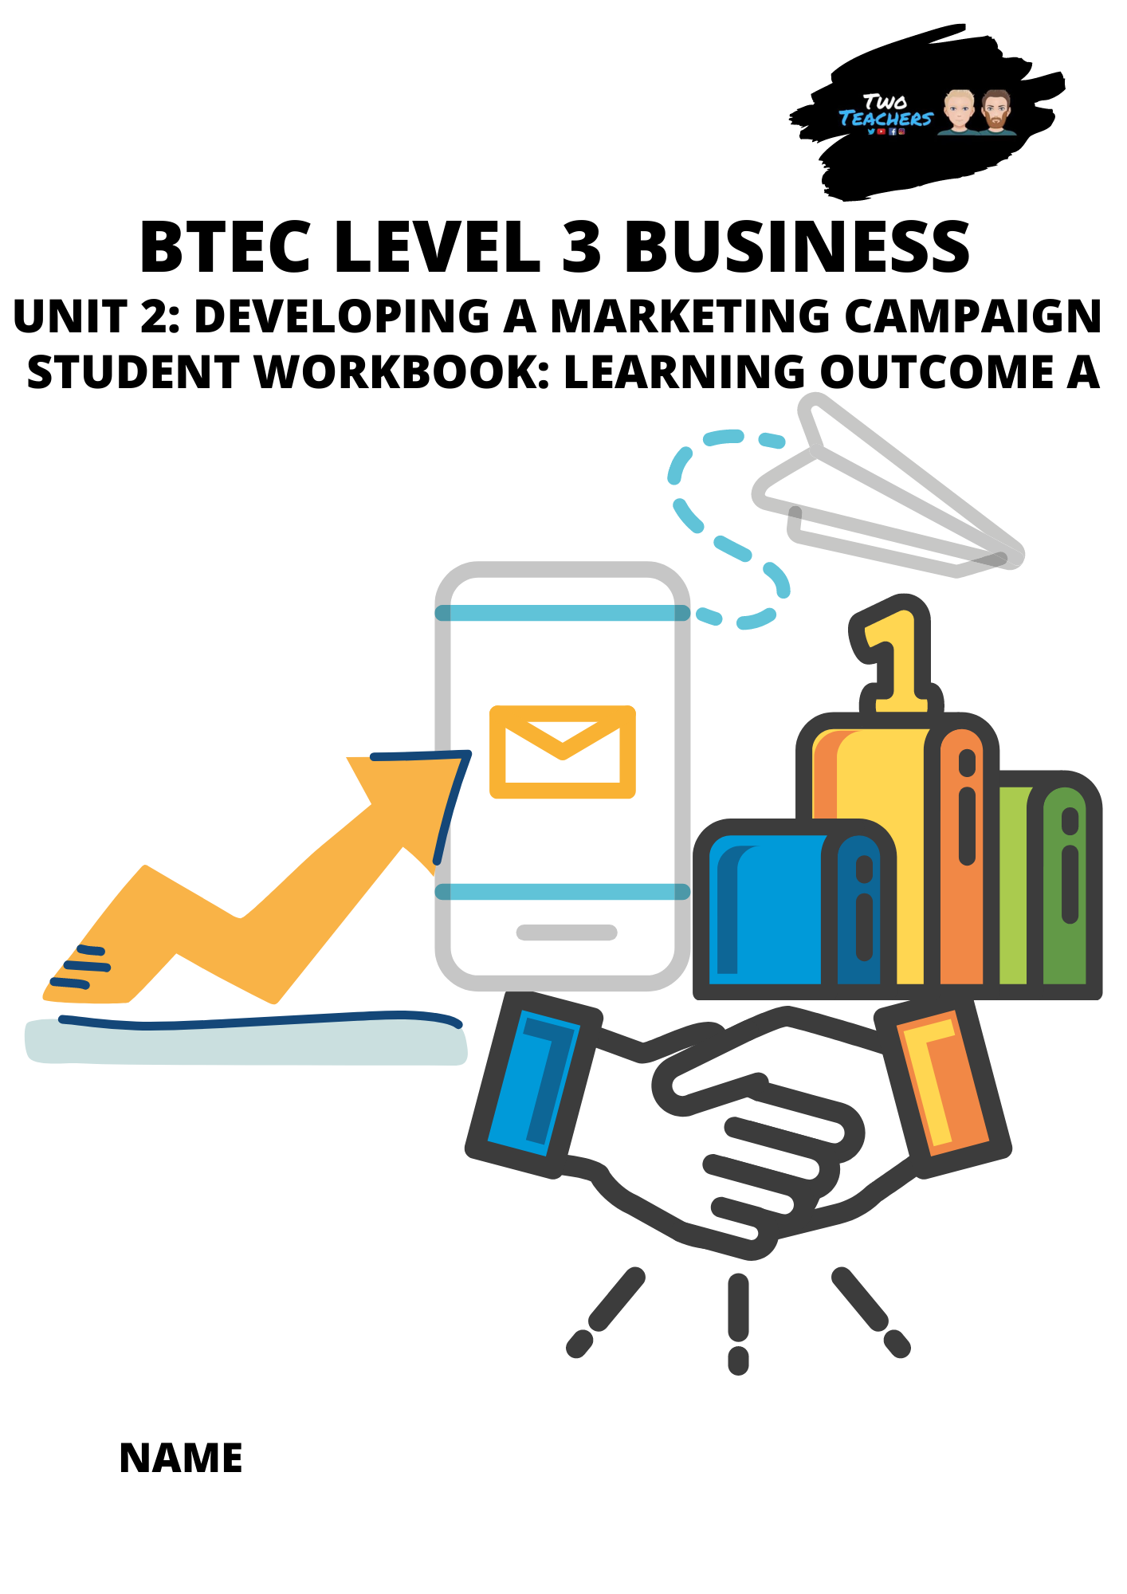

Unit Specification: Unit 2: Developing a Marketing Campaign

Method of Assessment:
Externally Marked Exam

Unit in brief
Learners will gain skills relating to, and an understanding of, how a marketing campaign is
developed.

Unit introduction:
Marketing is a dynamic field central to the success of any business. You will gain an understanding of how a marketing campaign is developed. You will explore different stages of the process that a business goes through when developing its campaign and develop your own campaign for a given product/service.

You will examine the marketing aims and objectives for existing products/services and understand the importance of relevant, valid and appropriate research in relation to customers’ needs and wants. You will use given market research data and other information to make recommendations about the type of marketing campaign that a business should undertake. To complete the assessment task within this unit, you will need to draw on your learning from across your programme.

This unit will give you an insight into how important marketing is to business. It will enable you to make an informed choice as to whether you want to specialise in marketing in employment, training or higher education.

Summary of assessment
This unit is assessed under supervised conditions. Part A is released two weeks before Part B is scheduled for learners to carry out research. Learners will take Part B in a supervised assessment in a single three-hour session timetabled by Pearson. The assessment is set and marked by Pearson.

The number of marks for the unit is 70. The assessment availability is twice a year in December/January and May/June. The first assessment was available in May/June 2017. Sample assessment materials are available to help centres prepare learners for assessment.

Assessment outcomes
AO1 Demonstrate knowledge and understanding of marketing principles, concepts, processes,
key terms, data sources and definitions
AO2 Analyse marketing information and data, demonstrating the ability to interpret the potential
impact and influence on marketing campaigns
AO3 Evaluate evidence to make informed judgements about how a marketing campaign should be
planned, developed and adapted in light of changing circumstances
AO4 Be able to develop a marketing campaign with appropriate justification, synthesising ideas and
evidence from several sources to support arguments

Activity 1: What is the Role/Purpose of Marketing?

Explain in your own words what you think marketing is all about below. (Hint: there are 3 key roles/purposes).

Role/ Purpose 1:

Role/ Purpose 2:

Role/ Purpose 3:

Activity 2: Famous Examples of Marketing

How many examples of marketing can you think of? Ensure you list at least 3 examples below and identify the business and what form of marketing it was. This can range from adverts to social media posts and beyond

Examples 1:

Example 2:

Example 3:

Activity 3 - The Role of Marketing Video and Activity

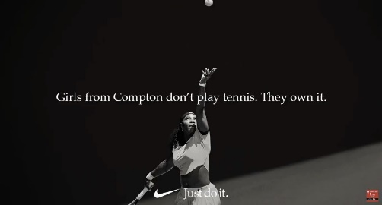
Watch the video named ‘The role of marketing - why does so much get spent on marketing?’ in the Two Teachers YouTube channel ‘Business Studies’ playlist and answer the following questions.
Video link: The Role of Marketing

Pre-video activities – Before you watch the video complete the two activities below:
- Of the 3 examples of marketing you identified in the previous task, choose your favourite and justify why you think it’s the best one.

- It is estimated that advertising spending worldwide will surpass 560 billion U.S. dollars in 2019, representing a growth of roughly four percent compared with the previous year. Justify why you think businesses spend so much money on marketing and what you think they might want to achieve from this?

Video activities – Answer the following questions once you have watched the video:

- Explain and compare the 3 purposes of marketing identified in the video and rank them in order of importance. Be critical, do you agree with these 3 purposes? What would you amend or add?

- Choose a business of your choice and create a plan for a marketing campaign that could compete with Nike’s ‘Dream Crazy Campaign’. Within your plan you should answer the following:
- What is your chosen business?

- What are the aims and purpose of your marketing campaign? Support your choices with valid reasons.

- Who is the target market for the marketing campaign and why?

- What type of adverts or promotions are you going to have and why?

- How will your chosen adverts or promotions help you to achieve your marketing aims and purpose? Ensure you justify your responses.

.

Activity 4: The Secret Behind Coca-Cola’s Marketing Strategy Activity

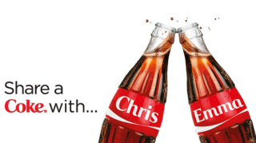

Watch the video named ‘The Secret Behind Coca-Cola’s Marketing Strategy’ in the Two Teachers YouTube Channel ‘Business Case Studies’ Playlist and complete the 5 activities below.
Video link: The Secret Behind Coca-Cola’s Marketing Strategy Activity

- Why do you think Coca Cola spends 10% of their sales revenue (approx. $4 billion) on advertising every year even though they are already so popular and well known?

- What is guerrilla marketing and why do Coca Cola use it?

- Analyse the repeated use of the same style Christmas advert campaign year on year, is it really needed?

.

- Which of Coca Cola’s marketing campaigns do you prefer, ‘Share a Coke’ (personalised names on bottles) or ‘Share a Can’ (twist cans). Ensure you justify your answers.

- If you worked in Coca Cola’s marketing team, what would you do for their next marketing campaign, be creative with this one, think about the aims of the campaign and justify your plan.

Activity 5: Guess the Brand

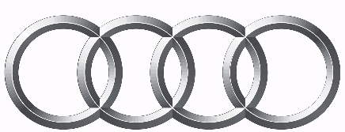










These should be instantly recognisable products/ services without any explanation, see if you can get 100% below.
What did you score out of 11?

PlayStation
Monster

Activity 6: Principles and Purposes of Marketing - Anticipating Demand

You and the person next to you work for Amazon as marketers, how might you anticipate the demand for the following products?
- Amazon Echo
- Lawnmower
- Laptop
- Football boots
Football boots:
Laptop:
Lawnmower:
Amazon Echo:

Activity 7: Principles and Purposes of Marketing - Recognising Demand

Following on from the anticipating demand scenario, with the person next to you, you are now required to suggest how you would recognise demand for the following products?
- Amazon Echo
- Lawnmower
- Laptop
- Football boots
Football boots:
Laptop:
Lawnmower:
Amazon Echo:

Activity 8: Principles and Purposes of Marketing - Anticipating and Recognising Demand

Read the small case study below on McDonald’s anticipating and recognising demand for a vegetarian happy meal and complete the following 4 activities:
- How did McDonald’s anticipate demand and how effective do you think this was?
- What methods did McDonald’s use to recognise demand and how effective do you think this was?
- What are the benefits of McDonald’s listening to customer demand?
- If you worked for McDonald’s, what new product would you introduce to increase sales and meet demand of the fast food customer market and why?

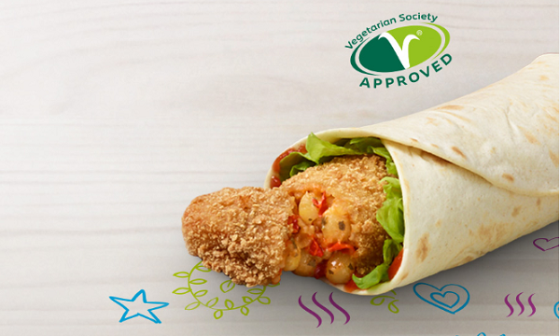

EXCLUSIVE: Recognising consumer demand, McDonald's introduces their first-ever vegetarian Happy Meal
The move comes after a third of their customers wanted more meat-free meals.
McDonald’s has recently launched their new vegan wraps for both adults and kids, including the first-ever vegetarian Happy Meal in the company’s history.
The Happy Meal Veggie Wrap consists of pesto goujons and a seasonal salad, wrapped around a tortilla. Meanwhile, their new Spicy Veggie Wrap also features the same ingredients along with red pepper and a spicy relish. It is also said to come at below 400 calories.
“At McDonald’s, we’re always working to improve our menu and that’s why we’ve introduced the delicious new Spicy Veggie Wrap and Veggie Happy Meal options.,” a McDonald’s spokesperson told QSR Media.
“The two new variants to the permanent menu offer customers more choice when it comes to selecting their meals. Having vegetarian choices offers a solution for customers looking to eat more meat free meals or get involved with consumer trends such as ‘Meat Free Monday’,” he added.
The new launches comes after 33% of their customers think that it’s important to include more meat-free meals into their diets. Both items are also approved by the British registered charity Vegetarian Society.
“We have listened to the wants and needs of our customers and their families and a third of our customers now agree it’s important to include more meat free meals into their family’s diets, so we have launched the first Veggie Happy Meal to meet this need,” their spokesperson added.
In addition, the new Happy Meal comes with either a Carrot Bag or Pineapple Stick as a side along with Organic Milk.
“Having vegetarian options offers greater choice for customers when it comes to selecting their meals and we will continue to develop our menu to offer customers a range of delicious meal choices,” their spokesperson added.
(Photo credit: McDonald's website)
- How did McDonald’s anticipate demand and how effective do you think this was?

- What methods did McDonald’s use to recognise demand and how effective do you think this was?

- What are the benefits of McDonald’s listening to customer demand?

- If you worked for McDonald’s, what new product would you introduce to increase sales and meet demand of the fast-food customer market and why?

Activity 9: Stimulating Demand

How do the associated businesses use the adverts below to stimulate demand?
KFC and Pizza Hut:

Compare the Meerkat and Cineworld:

T-Mobile:


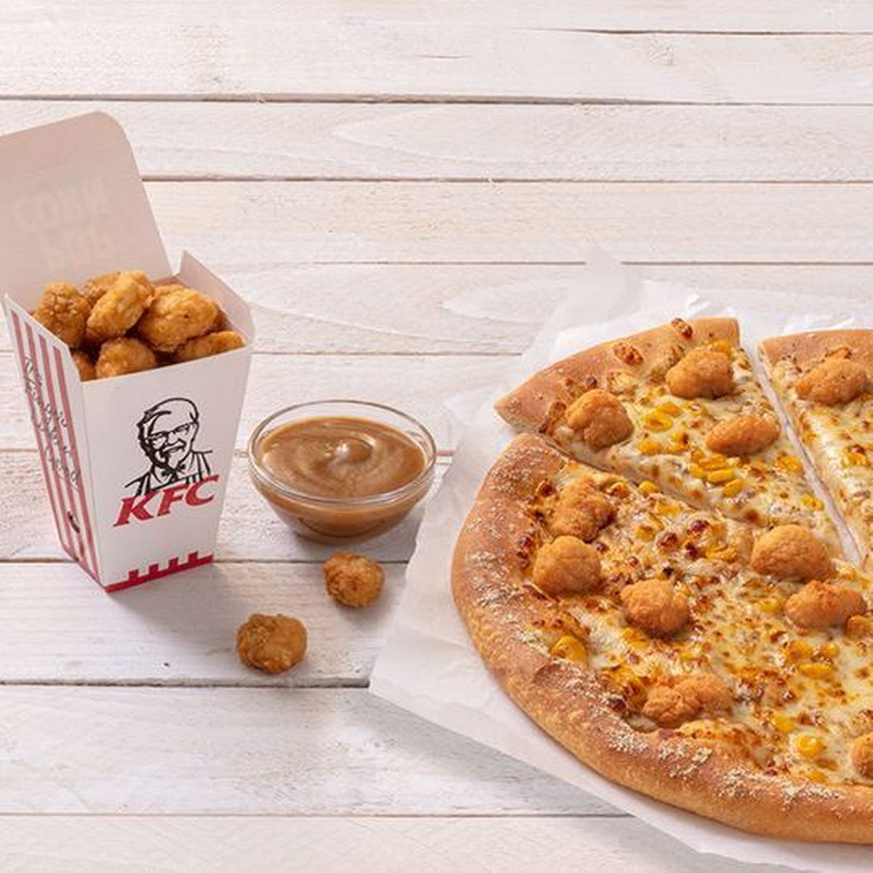

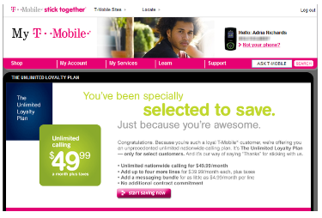

Activity 10: Stimulating Drake’s Demand

Drake owns a hybrid store, it is a music shop, where he sells merchandise and also provides tuition to music students, such as how to DJ and produce music. The store also has a cafe, which at night, turns into a bar with live music. However, business has started to decline and Drake wants to grow the revenue and popularity of all the different products and services he offers. He has a budget of £250 for marketing. Help Drake by completing the 4 activities below:

- Make recommendations (minimum of 2) which would help Drake to stimulate demand for his business, ‘Hotline Bling’ through the various methods of marketing available.

- Justify the recommendations you’ve made, suggesting why you think they will be successful, ensuring you also consider the possible drawbacks of your recommendations.

- Create supporting marketing aims and objectives for each recommendation you’ve made.

- Compare your recommendations with a peer in your class to gain constructive feedback on your ideas and in return provide them with constructive feedback for theirs.
What are your peer’s recommendations for Drake?

What do you think of their recommendation’s, write your constructive feedback below:

What constructive feedback did your peer provide you about your recommendations for Drake?

Activity 11: Principles and Purposes of Marketing - Satisfying Demand

Apple’s Rising Research and Development Costs

Why do you think there is an upward trend in Apple’s research and development spend as a percentage of their sales?

What are the possible consequences if they do not continue this trend?

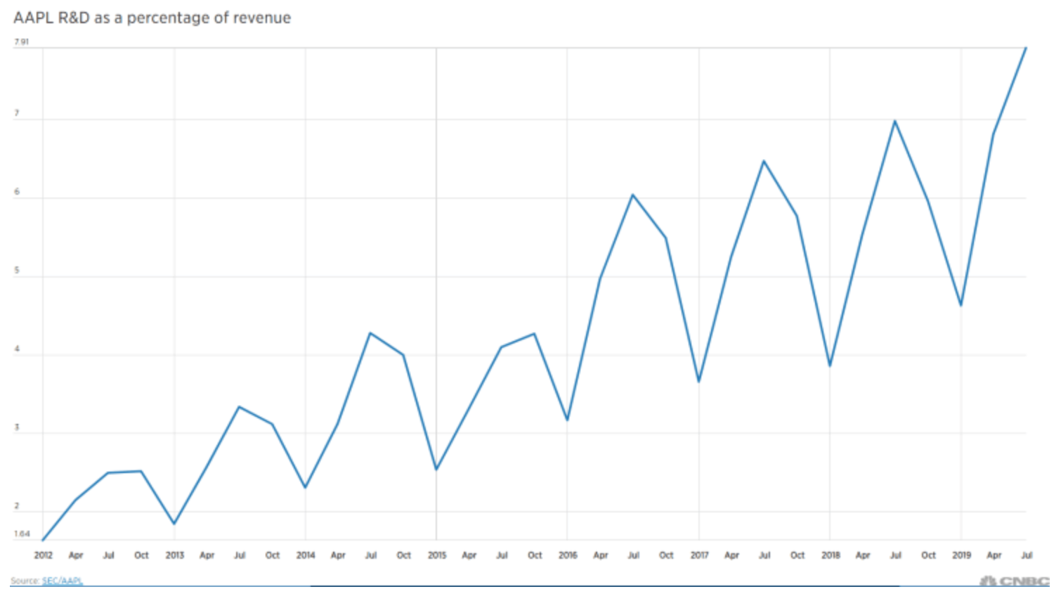
What do you think could be the next breakthrough product or service from Apple and why?

Activity 12 - Marketing Aims and Objectives - Understanding Customer Wants and Needs

Chicken Connoisseurs Part 1: believe it or not but it is someone’s job at KFC to actually taste their ‘finger lickin’ chicken. This is just one-way KFC gain feedback to understand the wants and needs of their customers.

You are the Head of Research and Development at KFC. You have been tasked with creating a new product and must choose just 3 research methods to gain as much information from KFC’s customers to understand their wants and needs, ensure you include the following points:

- Explain which 3 methods you would choose over other alternative research methods and justify why. Also, ensure you provide the advantages and disadvantages of each chosen method.
Research Method 1

Research Method 2

Research Method 3

Activity 13: Marketing Aims and Objectives - Developing New Products

Below are just some of the key stages involved when developing new products, discuss what you think happens at each stage and see if you can put them in the correct order:

Product Development
Test Marketing
Idea Generation
Product Launch
Development of the Marketing Strategy

- Describe what happens at each stage in the boxes below:
Product Development:

Research Method 2

Research Method 3

Test Marketing:
Idea Generation:

Research Method 2

Research Method 3

Product Launch:

Research Method 2

Research Method 3

Development of the Marketing Strategy:

Research Method 2

Research Method 3

- See if you can put each stage in the correct order below

Activity 14: Marketing Aims and Objectives - Developing New Products

Chicken Connoisseurs Part 2: now you have chosen 3 research methods to gain as much information from KFC’s customers to understand their wants and needs, you are now required to design a new product for KFC by completing the 4 activities below:

- Explain your product idea

- Justify why you believe it meets the wants and needs of KFC customers

- Explain how you will conduct test marketing on the product

- Justify your chosen methods of marketing for the product

Activity 15: Marketing Aims and Objectives - Improving Profitability

Watch the KFC advert and analyse its effectiveness with emphasis on how you think this could help to improve KFC achieve their marketing aim of improving profitability.
Video link: KFC Advert

- Do you think this advert would help KFC improve their profitability? Justify your answer either way

- Do you think the main marketing aim of this advert is to improve profitability or do you think KFC would have had different marketing aims and objectives when producing this advert?

- If you were the head of marketing for KFC and you had to create a marketing campaign to improve profitability, what would you do? You are not limited to a TV ad, you can do anything

Activity 16: Marketing Aims and Objectives - Increasing Market Share

Analysing Tesco’s Marketing Aims and Objectives: watch the Tesco advert from May 2020 and complete the following 2 activities. Video link: Tesco Advert

- Do you think Tesco had the marketing aims and objective of increasing market share for this advert? If so, how effective do you think it was in relation to increasing market share?

- Conduct research to find three different pieces of marketing that Tesco have produced over the years and answer the following questions:
- Analyse the purpose of each piece of marketing, what were Tesco trying to achieve?
- How effective do you believe it would have been?
- If you could only choose one of the three, which would it be and why?
Which advert and why?

Tesco Marketing Example 1:

Tesco Marketing Example 2:

Tesco Marketing Example 3:

Activity 17: Marketing Aims and Objectives - Diversification

Research and find a business that has diversified their product portfolio. Once you have found a business, answer the 4 questions below:

- What is your chosen business and what was its original product?

- How has it diversified? i.e. what product or products (this can also be a service) did it add to its portfolio and why were these added. Use as many examples as you can find.

- What was your favourite addition to your chosen business’ portfolio? justify your answer.

- Critically analyse the diversification of your chosen business, what are the benefits and drawbacks of this to the business and its customers.

Activity 18: Marketing Aims and Objectives -
Increased Brand Awareness and Loyalty

What brands are you loyal to? List 3 brands that you show loyalty to through your buying behaviour. Once you have identified your top 3 brands, explain what they do better than their closest competitors to make you become a loyal customer.
Brand 1:

Why are you loyal to this brand? What do they do better than their closest competitors to make you become a loyal customer?
Brand 2:

Why are you loyal to this brand? What do they do better than their closest competitors to make you become a loyal customer?
Brand 3:

Why are you loyal to this brand? What do they do better than their closest competitors to make you become a loyal customer?
Activity 19: Types of Market – Mass and Niche Market

Create a potential business that could operate within a niche market for the next 5 to 10 years by completing the 5 tasks below. You must consider the long-term success of your business when generating ideas as you will aim to progress into a mass market business after 10 years.

- What is your niche market business and what will it sell?

- How will you ensure you attract customers within such a small market?

- Are there any competitors in this niche market, what are their strengths and weaknesses and how will you differentiate yourself from them?

- How will you expand and evolve your niche market product range to operate within the mass market?

- What implications can you foresee on your business and customers base when progressing to the mass market from the niche market?

Activity 20: Market Segmentation

Compare the 3 products below and identify the main characteristics of their target audience within each market segment including their demographics, geographic, behavioural, and psychographic traits.


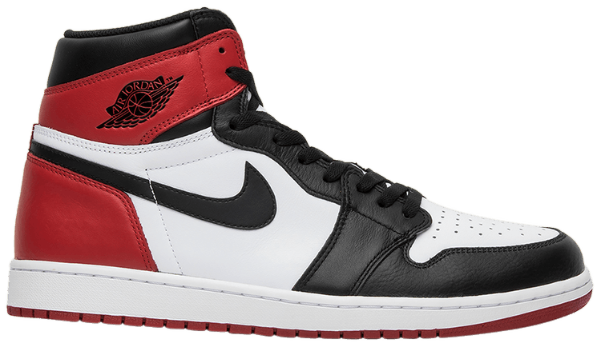
Main demographic characteristics:

Main geographic characteristics:

Main behavioural characteristics:

Main psychographic characteristics:

Main demographic characteristics:

Main geographic characteristics:

Main behavioural characteristics:

Main psychographic characteristics:

Main demographic characteristics:

Main geographic characteristics:

Main behavioural characteristics:

Main psychographic characteristics:

Activity 21: Branding

To show how effective branding is, see if you can recognise the 5 brands below just from their colour scheme, logo or slogan. Once identified, explain what characteristics you associate with the brand when you see it. For example, you might associate Audi with being luxurious, expensive, fast, and stylish.


The brand:

Characteristics you associate with the brand:


The brand:

Characteristics you associate with the brand:



The brand:

Characteristics you associate with the brand:

The brand:

Characteristics you associate with the brand:

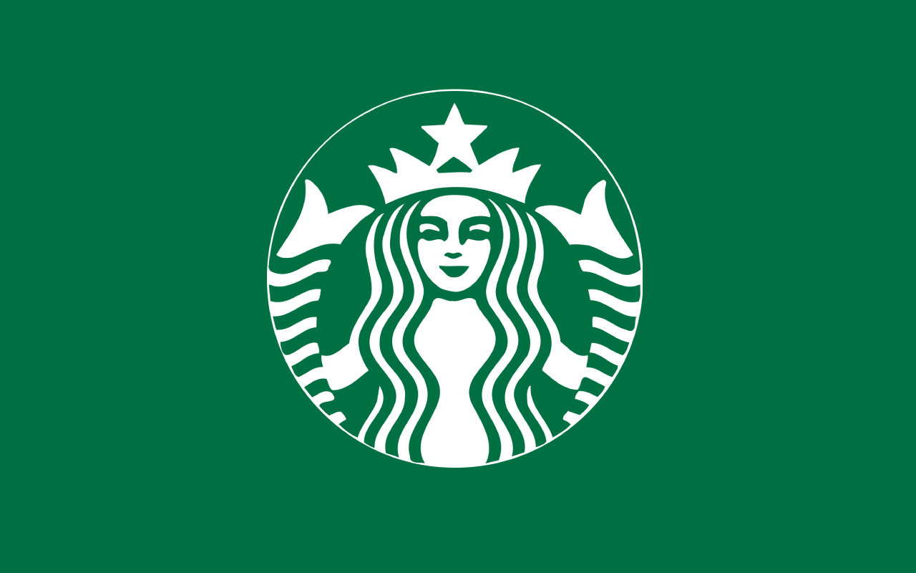


The brand:

Characteristics you associate with the brand:

Activity 22: Brand Values System

Look at the 5 brands below and rank them in your values system with justification of their position.


Rank out of 6:

Why did you rank this brand in this position in your values system?

Rank out of 6:

Why did you rank this brand in this position in your values system?



Rank out of 6:

Why did you rank this brand in this position in your values system?


Rank out of 6:

Why did you rank this brand in this position in your values system?


Rank out of 6:

Why did you rank this brand in this position in your values system?


Rank out of 6:

Why did you rank this brand in this position in your values system?

Activity 23: Brand Personality

Analyse the 5 brands below and complete the following 3 tasks for each:

- If this brand were a person, how would it act? what would its personality traits be? How would it look and dress?
- How does this brand’s personality compare with the other four? What are the key differences and are there any similarities?
- Do you shop with this brand? If not, why not? and if so, do you see similarities between your own personality and the brands?

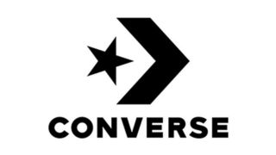





Activity 24: Brand Image

Apple is number one on Forbes ‘The World’s Most Valuable Brands’ list, yet Samsung who directly compete with them, especially in the phone industry, are only 7th, even though they have a much wider and diverse product range. Invest the reasons by completing the following 3 tasks:

- What are the key differences between the Apple and Samsung in terms of brand image?

- What makes Apple so much more valuable in your opinion?

- If you were the CEO of Samsung, what would you do to close this gap and become a more valuable brand?

Activity 25: Unique Selling Point

We all know how important an effective USP is to the success of a business. Let’s see if you can complete the crossword puzzle and guess all 10 businesses based purely on information about their unique selling point.
 |  |  |  |  |  |  |  | 1
 |  |  |  |  |  |  | 2
 |  |  |  |  |  |  |  |  |  |  |  |  |  |  | 3
 |  |  |  |  |  |  |  |  |  |  | 4 |  | 5
 |  |  |  |  |  |  | 6
 |  |  |  |  |  |  |  |  |  | 7
 |  |  |  |  |  |  | 8
 |  |  |  | 9 |  | 10

Across  2. A shoe manufacturer who pledges "for every pair of shoes a customer purchases, the company donates a pair to a child in need".  6. Providing superior engines and the latest technology within the sports car industry for affluent and elite customers.  7. A major player in the logistics market, promising to transport your package quickly and securely. It's slogan was once "when it absolutely, positively has to be there overnight”.  8. This food retailer earned their recognition not by promising the cheapest prices, or the widest selection of products. Instead, they focused on creating “value” for customers by promising to “treat people the way we like to be treated." Famous for their slogan, 'every little helps'.  9. This famous coffee shop pledges "Love your beverage or let us know. We’ll always make it right". | Down  1. Their USP lies in providing you with the information you're searching for, without having to search through thousands of sites to find the quality information you are searching for or having to pay for that kind of service.  3. Their USP is that their chocolate will melt in your mouth, not your hands.  4. A social utility that connects you with people around the world, helping you to share moments and catch up with the people in your life, with over 2.6 billion active users monthly.  5. This brand's focus is primarily on athletic shoes with prominent sponsorship with star athletes. Their USP is that they provide the best quality shoes for athletes and fitness in general.  10. This supermarket chain has the USP of having cheaper in-house alternatives of everyday grocery items.

Activity 26: Budgetary Constraints

Try to correctly match up the 3 statements to the 3 businesses below by drawing a connecting line, then attempt the question about SME marketing budgets.




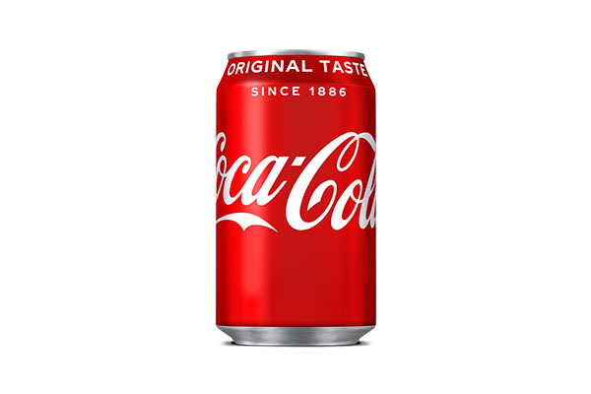
3%
11%
16%
Question: what % of their sales revenue did the average UK SME owner put into their 2018/19 marketing budget
1. Spent $4.24bn in 2019 for advertising and marketing

2. Their digital advertising strategy in 2019 was that their ad spend decreased by a drastic 68%, down to $76.3M from $243M in 2018
3. The company spent $3.75 billion on marketing in 2019

Activity 27: Budgetary Constraints

Let’s have a look what this data means for marketing budgets in the UK by answering the following questions below, ensure you show your workings:

1.If 16% of this average turnover of a micro business (£286,879) was spent on marketing, it means the average marketing budget is?

2. If 1 in 5 micro businesses across the UK operate on a turnover less than £50,000 and on average they spend a quarter of this on marketing, what would their marketing budget be?

3. If this was reduced to just 5% of turnover (£50,000), what would the average marketing budget be for a microbusiness?

Activity 28: Availability of Specialist Staff

Discussion point : looking back at the previous data about the typical number of employees for different sizes of business, what impact do you think this has on a business’s ability to conduct effective marketing depending on how many staff it employs?

  - 0.6% are medium-sized businesses (50 - 259 employees)
  - Less than 4% are small businesses (10 - 49 employees)
  - 96% are microbusinesses (0 - 9 employees)
Answer the following 3 questions for each of the business types listed below:

- Consider who would potentially conduct the marketing for the business.
- What impact do you think this has on a business’s ability to conduct effective marketing?
- Compare the benefits and drawbacks for the business of your above answer.
Micro Business:
Large and Multinational Business:
Medium Business:
Small Business:
Sole Trader:
Activity 29: Implications of Business Size for Marketing Activity

Choose either scenario 1 or scenario 2 below and create a poster in the box below that explores the marketing activity of the businesses and how the differences in size, budgetary constraints and availability of specialist staff impacts their marketing activities with supporting examples.
- Scenario 1: A local corner shop vs. Sainsbury’s Local
- Scenario 2: A family run sports shop vs. Sports Direct

Activity 30: Internal Influences: Cost of the Campaign

The cost of a marketing campaign will vary according to the needs and wants of the business it is being created for and the marketing company they hire (if they don’t conduct the campaign in house). With this in mind, let’s see if you can accurately guess the costs of the marketing campaigns below (research is allowed).

- Nationally, the average cost of social media marketing is between £ to £ ?

- There are two television advertising costs: buying adverts spots between TV shows in the UK. For example, rates for the smaller digital channels start at around £ to

£ for daytime and up to £ to £ for peak time.

- TV adverts during Good Morning Britain or Lorraine can cost between £ to £

- The production costs for making the TV advert typically ranges from around
£ for a very simple TV commercial to £ for a blockbuster TV advert with top stars and a famous music track.

- It is possible to start a TV advertising campaign for as little as £ and with TV advertising delivering an average of £ returned for every £1 invested in the first 3-6 months Television advertising can turn sales around.

- A business can expect to pay anything between £ for a quarter of a page on a local newspaper and £ for a full-page advert on The Daily Mail.

- As a general rule for radio advertising, every 1000 listeners will cost £

- For a magazine with a readership of 5,000 people, you can expect to pay £ for a full-page ad or more.

- Tribe (an Influencer Marketing Agency) suggests that its top influencers in the UK area are earning £ per post and up to £ per week through the platform.

- The two-and-half-minute John Lewis Christmas advert campaign in 2019 starring the excitable Edgar who loves everything about Christmas but can’t control his fiery dragon breath cost the business £

Activity 31: Internal Influences on a Marketing Campaign

In 2017, Pepsi created a marketing campaign in-house. They hired Kendall Jenner for the campaign, but it backfired and was heavily criticised. After watching the advert, answer the questions below. Video link: Kendall Jenner Pepsi Advert

- Why do you think the advert caused anger and upset amongst viewers?

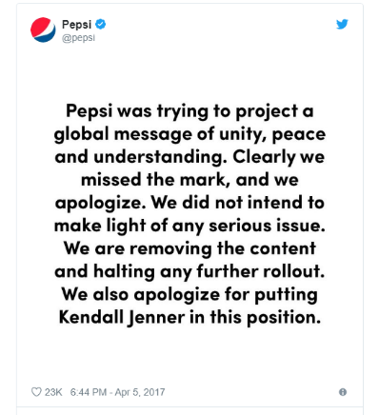
- Pepsi tweeted this response to the backlash on social media, do you think this was the right response and did they even need to apologise? Justify your response either way and generate an alternative way in which Pepsi could have responded.

- Lead marketer Mark Ray blames the failings of this marketing campaign on Pepsi’s lack of specialised staff. Do you agree with him? Justify your answer either way and if you disagree what do you think were the key reasons for this marketing campaign failing.

- You are the Head of Marketing for Pepsi and you have been given the opportunity to work with Kendall Jenner for an upcoming marketing campaign which includes a TV advert and social media campaign. Justify what you would do below, you have an unlimited budget.

Activity 32: External Influences – PESTLE

We are now going to look at the external influences on a business’ marketing activities, which are also known as PESTLE factors. You are required to choose a business of your choice; this can be a local sole trader, right up to a global business. For your chosen business you are required to complete each step of a PESTLE analysis below after it has been covered on the PowerPoint slides.

Your chosen business:

Political factors and how they influence your chosen business’ marketing activities

Economic factors and how they influence your chosen business’ marketing activities

Social factors and how they influence your chosen business’ marketing activities

Technological factors and how they influence your chosen business’ marketing activities

Legal factors and how they influence your chosen business’ marketing activities

Environmental factors and how they influence your chosen business’ marketing activities

Activity 33: Advertising Standards Agency

The ASA have banned many adverts over the years, but some have gone unpunished even though they received complaints. Give you opinion on the following adverts and what you think the ASA should have done. Video link: ASA Banned TV Adverts

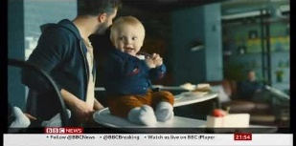
- Gender stereotyping law bans these two adverts. Watch the quick news clip on the PowerPoint about two adverts the ASA have banned, do you agree justify your opinion in your below?

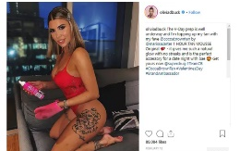
- Olivia Buckland’s Instagram post promoting fake tan was banned as it was not clearly identified as an ad, do you agree? justify your opinion in your workbook?

- Time to play ‘banned or not banned’. All you have to do is view the adverts below and state whether you think the adverts should be banned or not with a supporting reason why.


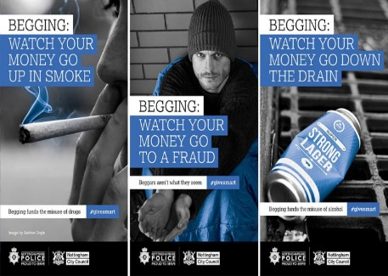
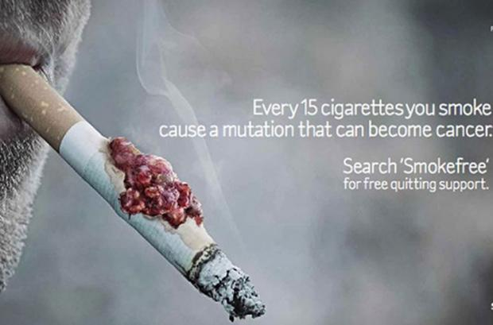

Banned or not banned?
Banned or not banned?
Banned or not banned?
Banned or not banned?

Activity 34: Learning Aim A Word Scramble

1. AMNITKERG _________________________________________
2. RBNADGNI __________________________________________
3. MTAKER MGNIEAOETNST _______________________________
4. NUEQIU LLSNGIE POTNI ______________________________
5. ITFPOR ____________________________________________
6. RBNAD ENWEARSAS ___________________________________
7. TARVDE ____________________________________________
8. FATFS RPTEIEXES ___________________________________
9. TARDYBEGU INTNSRSOTCA _____________________________
10. DNABR EILYONSARPT _________________________________

Activity 35: Learning Aim A Crossword

 |  |  |  |  |  |  |  | 1
 |  |  |  |  |  | 2 |  |  |  |  |  |  |  | 3 |  |  |  | 4
 |  |  |  |  |  |  |  |  |  |  | 5
 |  | 6
 | 7
 |  |  | 8 |  |  |  | 9
 | 10

Across  2. An external influence on marketing which is cyclical in nature  6. This is when a business expands their product portfolio into new markets  7. This is when a business splits its customers by the following characteristics: demographics, geographic, behavioural and psychographic  9. The elements and characteristics that makes one business or its associated products different to its competitors  10. This is a set of human characteristics that we associate with a product or service. | Down  1. This type of business makes up 96% of the UK's registered businesses  3. Finish the sentence: one key marketing aim and objective is to improve  4. This is the first stage when a business is developing new products  5. Businesses that sell products which are aimed at a small and specific segment of the market are operating in which type of market?  8. It should be instantly recognisable without any explanation

Activity 36: Learning Aim A Word Search

D | J | Y | D | Y | S | B | W | E | K | R | Q | G | E | M | C | K | N | K | A | M | S | C | S
X | F | S | B | A | I | O | H | U | B | Z | G | C | S | S | J | R | Y | V | L | S | D | Q | J
L | K | R | P | N | Q | U | L | R | Z | P | Q | W | C | M | K | G | A | Y | L | W | I | P | W
E | S | A | F | M | H | X | E | O | C | K | U | V | B | E | J | V | X | J | F | K | V | E | O
S | A | H | N | S | I | G | Q | P | V | D | V | R | W | L | T | M | J | S | B | B | E | M | Q
B | V | P | Z | S | J | I | D | E | A | G | E | N | E | R | A | T | I | O | N | U | R | N | I
T | Z | P | I | E | U | M | A | G | Z | D | X | J | D | M | Z | M | Q | A | D | K | S | X | N
F | V | S | P | N | G | H | F | M | R | P | O | D | X | B | E | A | D | A | R | V | I | U | O
Y | L | X | C | I | B | O | V | N | H | H | J | A | Y | B | A | B | N | H | T | T | F | D | I
F | F | P | Z | S | E | D | V | U | S | P | Z | T | S | B | N | W | G | C | E | K | I | V | T
G | E | J | V | U | J | V | N | T | B | E | I | O | S | J | K | U | S | V | W | B | C | R | A
E | Y | L | X | B | F | H | I | H | B | L | R | D | F | A | M | T | E | O | L | Q | A | E | T
C | Y | L | N | O | U | U | S | J | I | V | H | V | Z | I | Q | P | B | R | E | I | T | G | N
O | O | N | D | R | Z | I | A | B | U | P | L | S | F | X | M | H | I | F | I | L | I | U | E
N | G | J | G | C | X | I | A | R | R | S | O | V | T | S | S | Q | X | D | O | M | O | H | M
O | T | I | A | I | Q | T | D | O | G | A | S | F | M | Z | A | G | N | K | T | L | N | O | G
M | S | S | D | M | I | K | O | K | B | H | Q | A | U | W | W | A | F | K | T | B | B | R | E
Y | Q | Z | U | F | M | X | H | N | Z | N | H | F | G | N | R | D | R | Q | T | A | P | B | S
K | H | S | O | X | W | O | B | W | R | G | W | I | P | B | O | P | G | Z | E | L | R | A | T
S | S | R | U | S | X | L | T | Z | D | T | N | Z | X | D | G | I | F | M | H | T | T | A | E
Z | P | Y | T | I | L | A | N | O | S | R | E | P | D | N | A | R | B | C | C | Y | N | C | K
J | K | T | H | F | S | U | F | Z | S | L | R | D | J | E | Q | J | I | W | I | D | E | L | R
L | W | G | M | D | G | D | B | Z | P | J | L | H | I | N | A | W | H | G | N | U | F | J | A
H | V | Y | X | N | F | W | A | K | X | F | G | W | H | H | A | K | F | G | F | E | P | T | M
Brand Idea Generation Profitability Diversification Niche Market Segmentation Brand personality USP Micro Business Economy

Activity 37: Learning Aim A Kahoot Quiz

Attempt the Kahoot quiz to test your knowledge of Learning Outcome A of Unit 2: Developing a Marketing Campaign. Once you have completed the quiz, answer the questions below to assess your strengths and areas for development.

- What did you score on the Kahoot quiz?

- What areas of Learning Outcome A can you identify as your strengths after playing the quiz?

- What areas of Learning Outcome A can you identify as your development areas after playing the quiz?

- How do you plan to develop the areas you have identified to increase your knowledge and understanding of these topics?

Activity 38: Developing a Marketing Campaign Specification Checklist

Well done, you have now completed the input and set activities for Learning Outcome A, you have one final task which is to complete the specification checklist below. First, you should explain the terminology and topic areas in the space provided and then tick the box in the last column when you feel exam ready with regards to that specific element of the specification.
Developing a Marketing Campaign Specification Checklist
Topic | Your explanation of the terminology | Exam Ready?
A: Introduction to the principles and purposes of marketing that underpin the creation of a rationale for a marketing campaign
A1: The role of marketing
Principles and purposes of marketing:
- anticipating demand
- recognising demand
- stimulating demand
- satisfying demand
Marketing aims and objectives:
- understanding customer wants and needs
- developing new products
- improving profitability
- increasing market share
- diversification
- increased brand awareness and loyalty
Types of market – mass and niche market
Market segmentation
Branding
Brand personality
Brand image
Unique Selling Point (USP)
Implications of business size for marketing activity
Budgetary constraints
Availability of specialist staff

A2 Influences on marketing activity
Internal influences:
- cost of the campaign
- availability of finance
- expertise of staff
- size and culture of the business.
External influences:
- social
- technological
- economic
- environmental
- political
- legal
- ethical

